**IP CO-LAB WEB PLATFORM**

**USER MANUAL**

1. **Administrator Tutorial Test**
   1. **Summary**

The purpose of the Tutorial or Basic Overview is to allow Users to obtain general information about the four main areas of IP law: trademarks, patents, copyrights, and trade secrets. Users may complete activities to access this information and to test their knowledge of IP law.

As always, the combination of the Tutorial information, activities and subsequent legal information do not constitute legal advice under any circumstances. All Tutorial Modules and Activities are and should be tailored to suit generic situations. All information is general and not suited for factual nuances that the User may be facing.

* 1. **Inputting Content**

1. Below, you will find the Administrator Home screen.

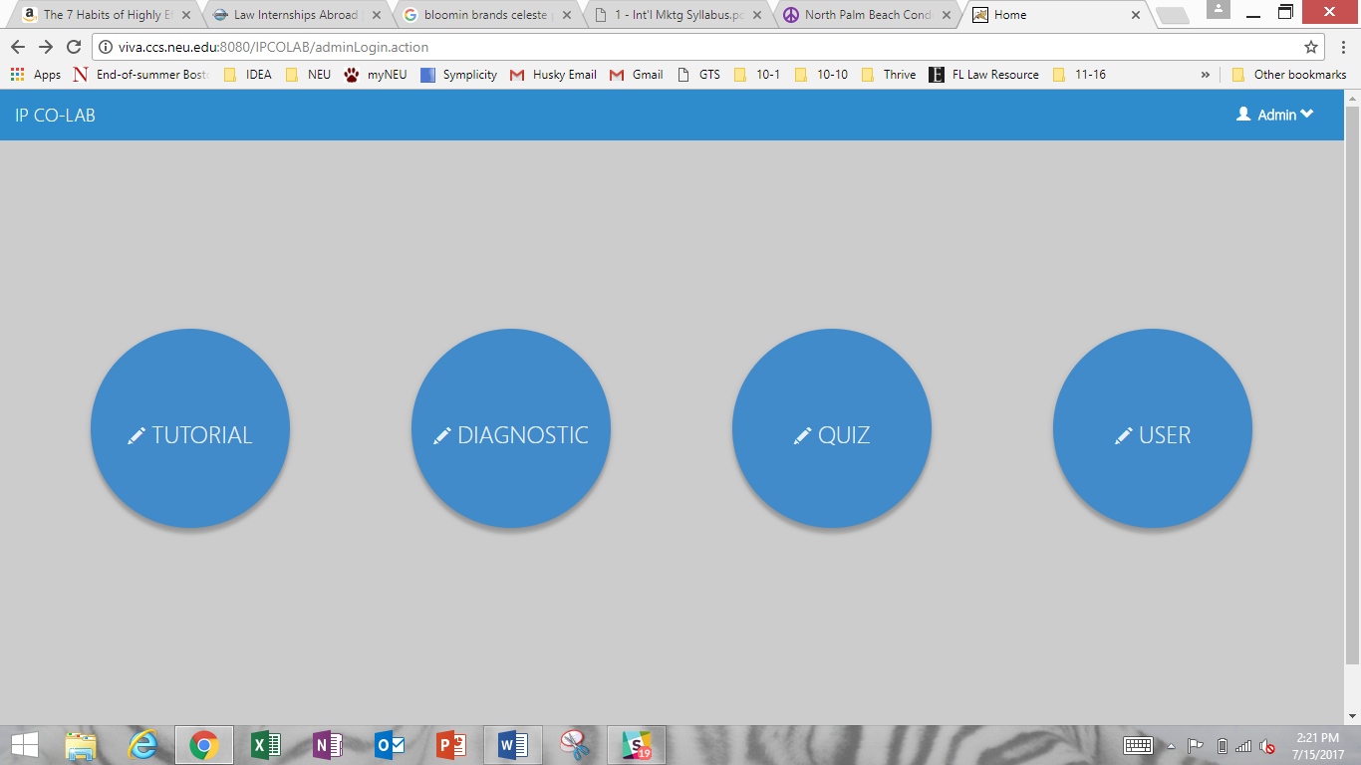

To access the Tutorial, click “Tutorial.”

1. You will arrive at a “Manage Tutorial” page where you can add, remove, and edit Topics, Modules, and Activities.

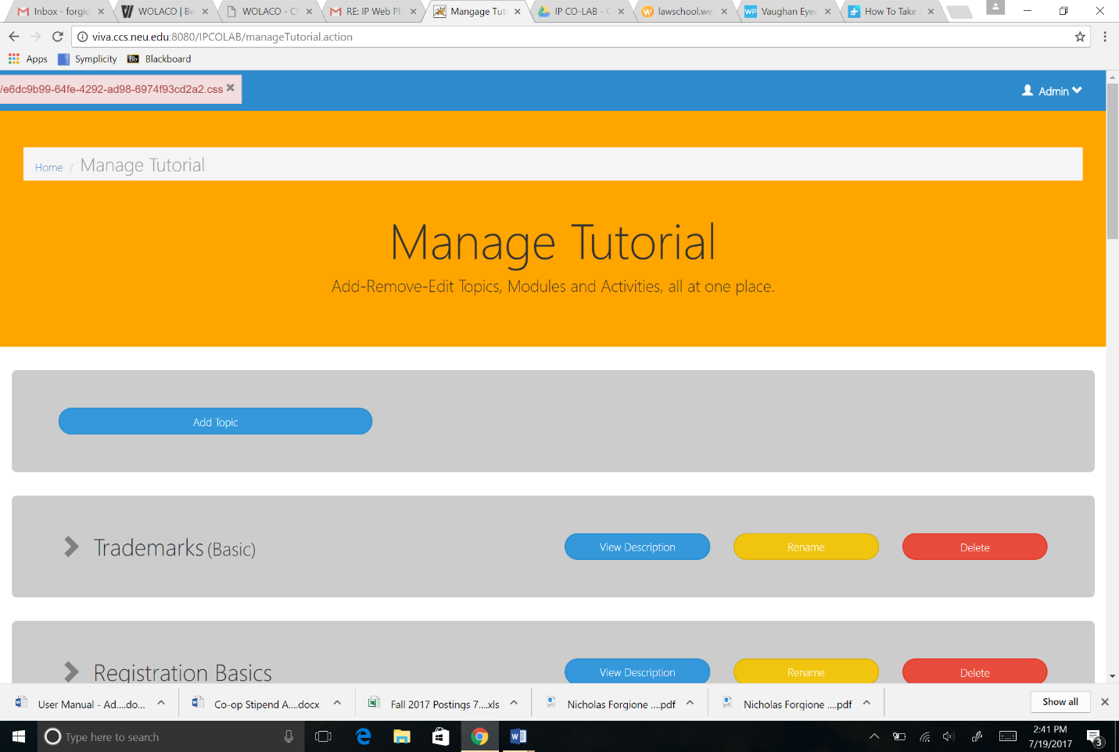

To add a new Topic, click “Add Topic.”

1. On the next screen, you can add the Topic Name at the top and a brief description of the Topic in the second text box.

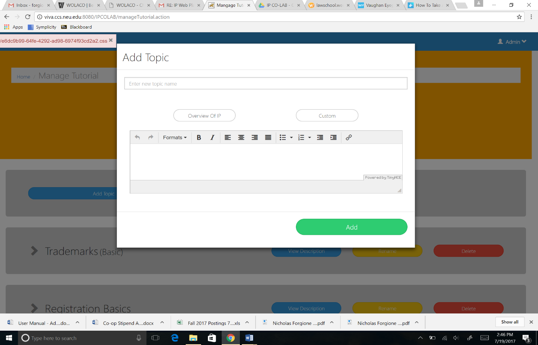

1. Beneath the Topic Name textbox, there are two options: “Overview of IP” and “Custom.” Selecting “Overview of IP” will create a Topic that is available to include in the Tutorial (Basic Overview) section of the platform. After selecting “Overview of IP” the new Topic will have “(Basic)” next to the name (see “Trademarks (Basic)” above). All activities that are subsequently added within this Topic will only appear within the User’s Basic Overview session.

Topics that are designated as “Custom” will be available only to create a Diagnostic Test. Nothing appears next to the Topic name to distinguish it as a “Custom” Topic. To create a Diagnostic Test, see the section in this manual “Administrator Diagnostic Test: Inputting Content.” At this time, you cannot select both “Overview of IP” and “Custom.”



When finished, click “Add.”

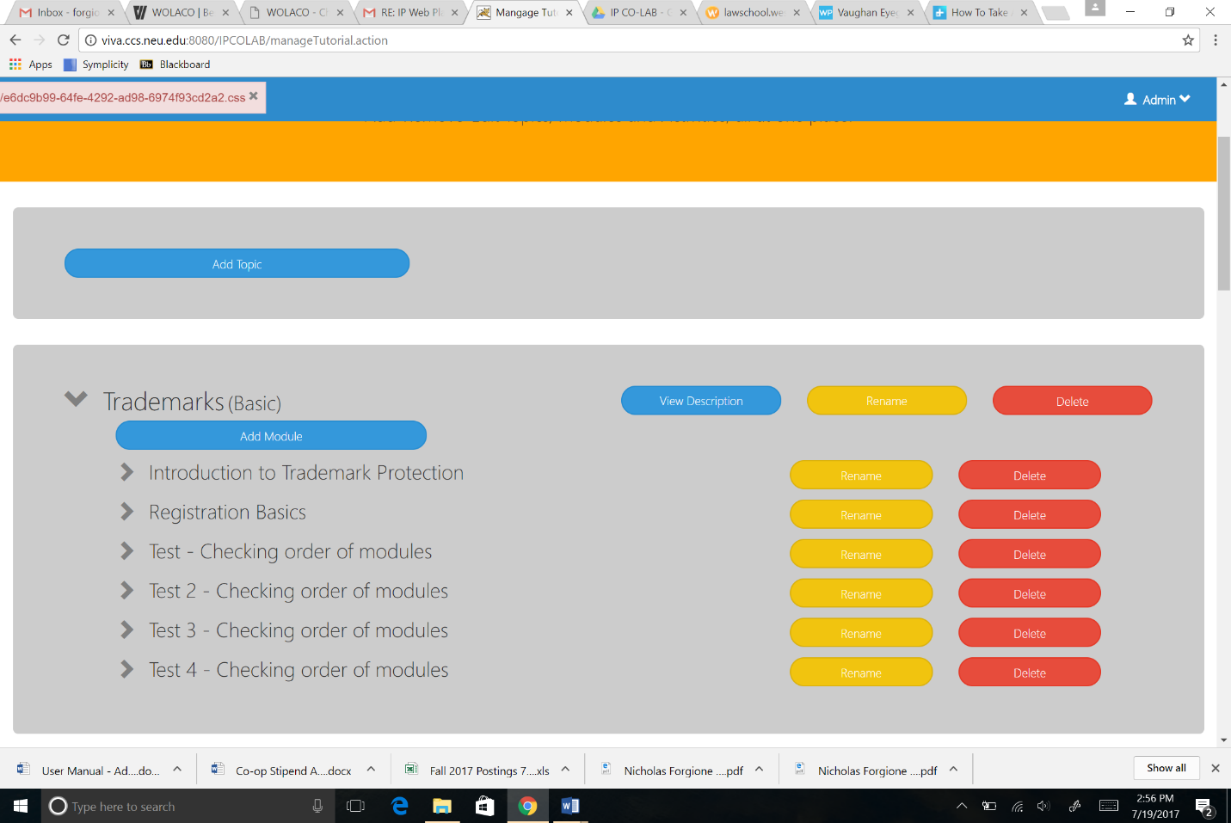

1. You may now use the Additional Features to View the Topic Description by clicking the blue “Description” icon, rename the Topic by clicking the yellow “Rename” icon, or remove the entire Topic by clicking the red “Delete” icon.
2. Next, add a Module within the Added Topic. Click “Add Module” to begin.

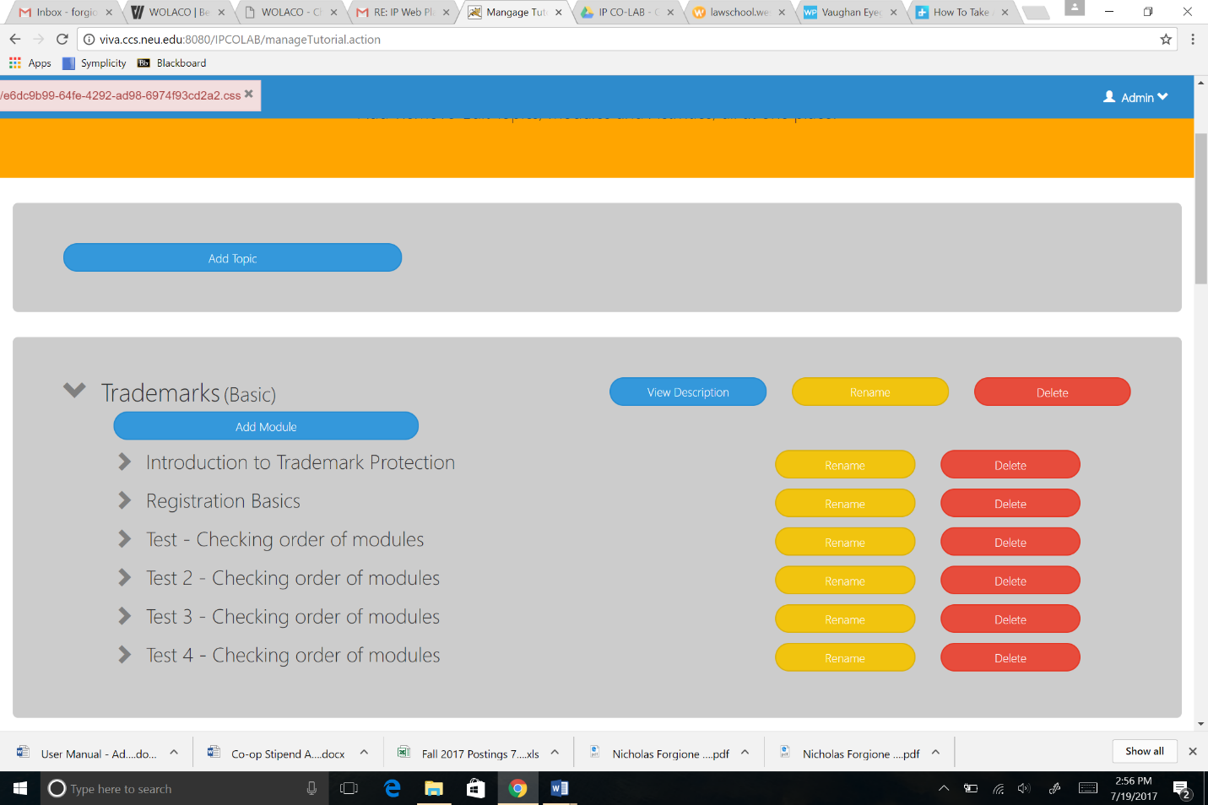

1. You will be prompted to enter a Module name. Click “Add” when finished.

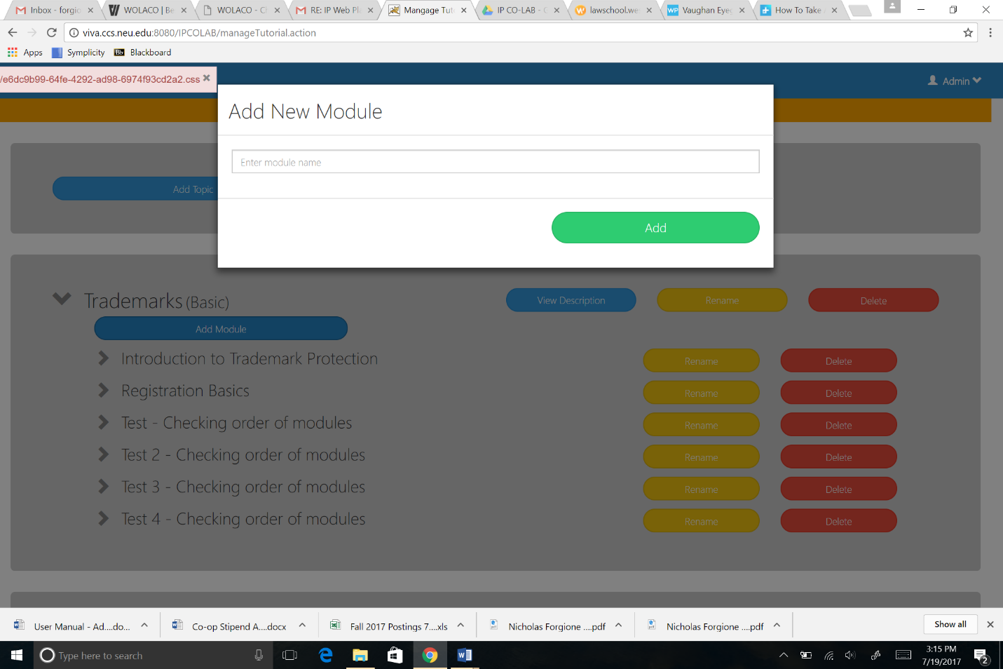

1. Your new Module will appear in a list under the Topic.



1. Next, add an Activity within the Module. Click the drop-down arrow next to the Module name, and then click “Add Activity.”

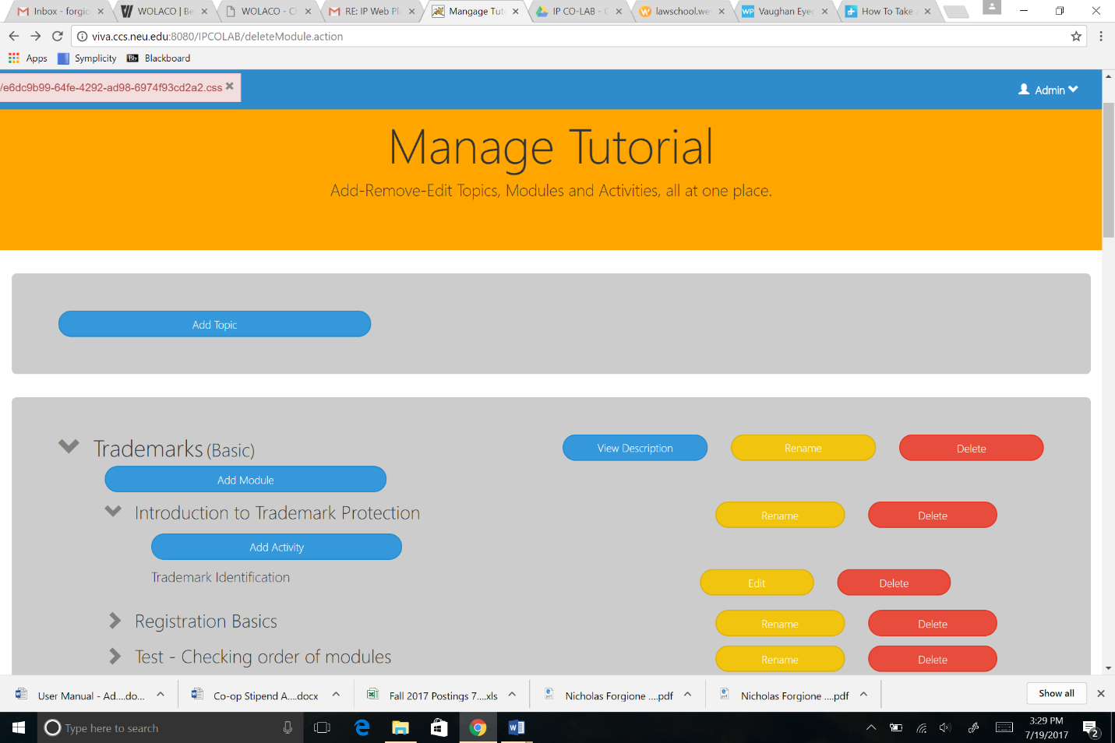

1. A new screen will open where you will follow five steps to customize the activity.
   1. First, choose the question template: Information (Text Only), Multiple Choice, Yes or No, Image or Video content.

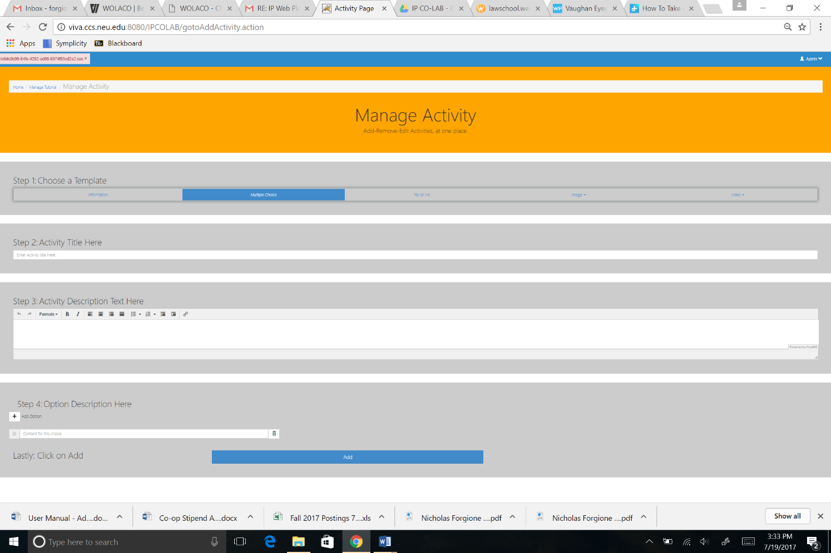

For a Video or Image template, choose the question type to accompany the image and video: Yes or No, Multiple Choice, or Description (Information Text Only).

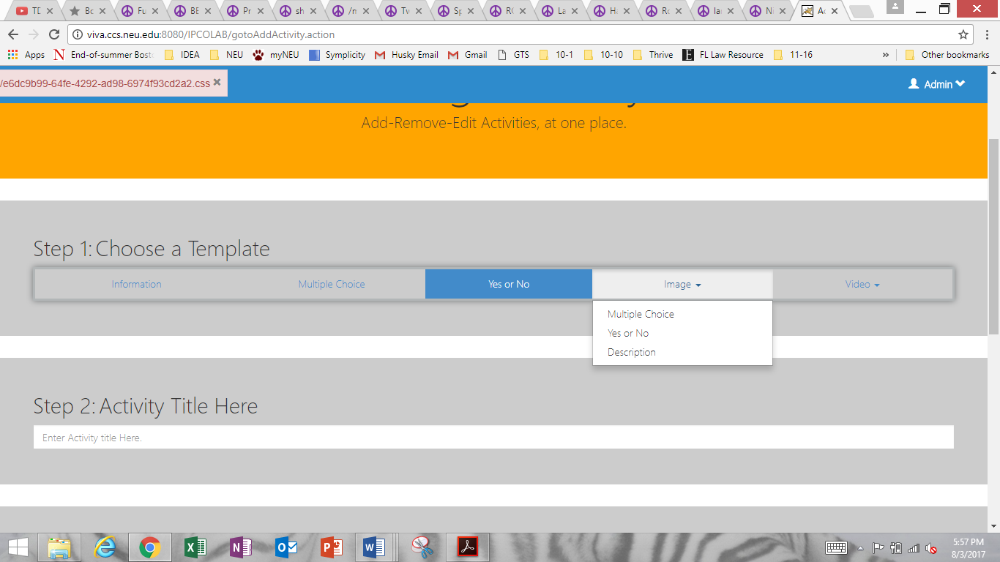 

* 1. Name the Activity.



* 1. Write the desired question in the “Activity Description” text box.
  2. What appears in Step 4 depends on the type of template chosen in Step 1. The Information (Text Only) template does not include this step.
     1. To edit a multiple choice template, click on the “+ Add Option” icon to add answer options. Select all correct answers by clicking on the small square next to the answer options.

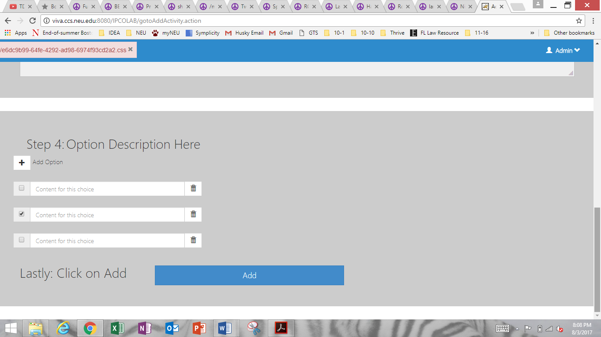

* + 1. Select “yes” or “no” as a correct answer for the Yes or No template.

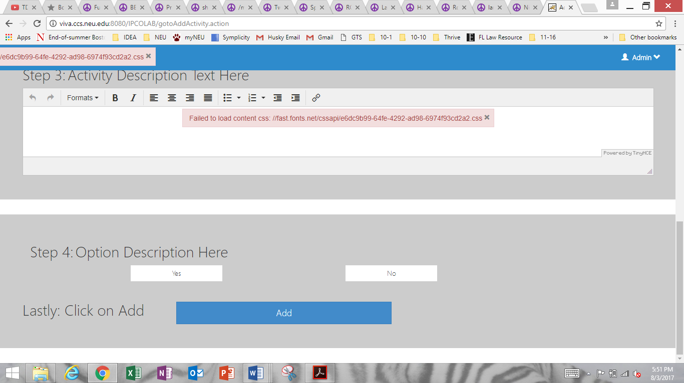

* + 1. For Video and Image formats, complete Step 4 according to the template type chosen in Step 1.



* 1. Click “Add” to finish.

1. The new Activity will appear under the Module in which you created the Activity. Edit or Delete Activities using the yellow and red buttons, respectively, adjacent to the Activity name.

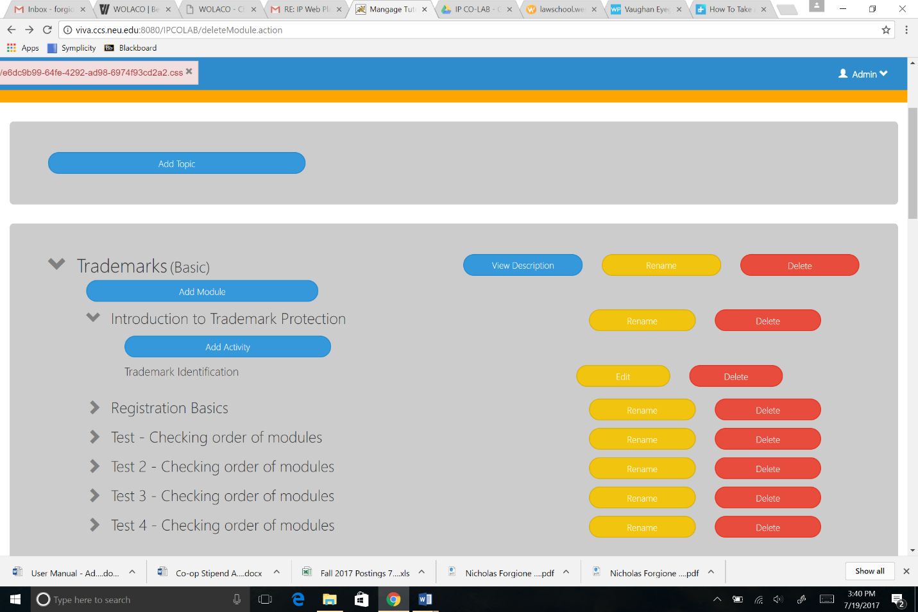

Repeat the above steps as necessary to populate the platform.

1. **Administrator Diagnostic Test**
   1. **Summary**

The purpose of the Diagnostic Test is to allow Users to obtain targeted legal information given generic situations that the User is interested in exploring. For example, a User may answer yes to a diagnostic question that asks if the venture consists of multiple collaborators, or no to a question that asks if the User is involved with a venture that is an established business entity. In either case, the Diagnostic Test will lead the User to information that takes the responses into account.

As always, the combination of the Diagnostic questions and subsequent legal information do not constitute legal advice under any circumstances. All Diagnostic questions are an should be tailored to suit generic situations. All information is general and suited for the generic situation, but not for factual nuances that the User may be facing.

* 1. **Inputting Content**

1. Below, you will find the Administrator Home screen.



To access the Diagnostic Test, click “Diagnostic.”

1. You should arrive at a “Manage Diagnostic” page where you can add, remove, and edit Diagnostic Categories and Diagnostic Questions.

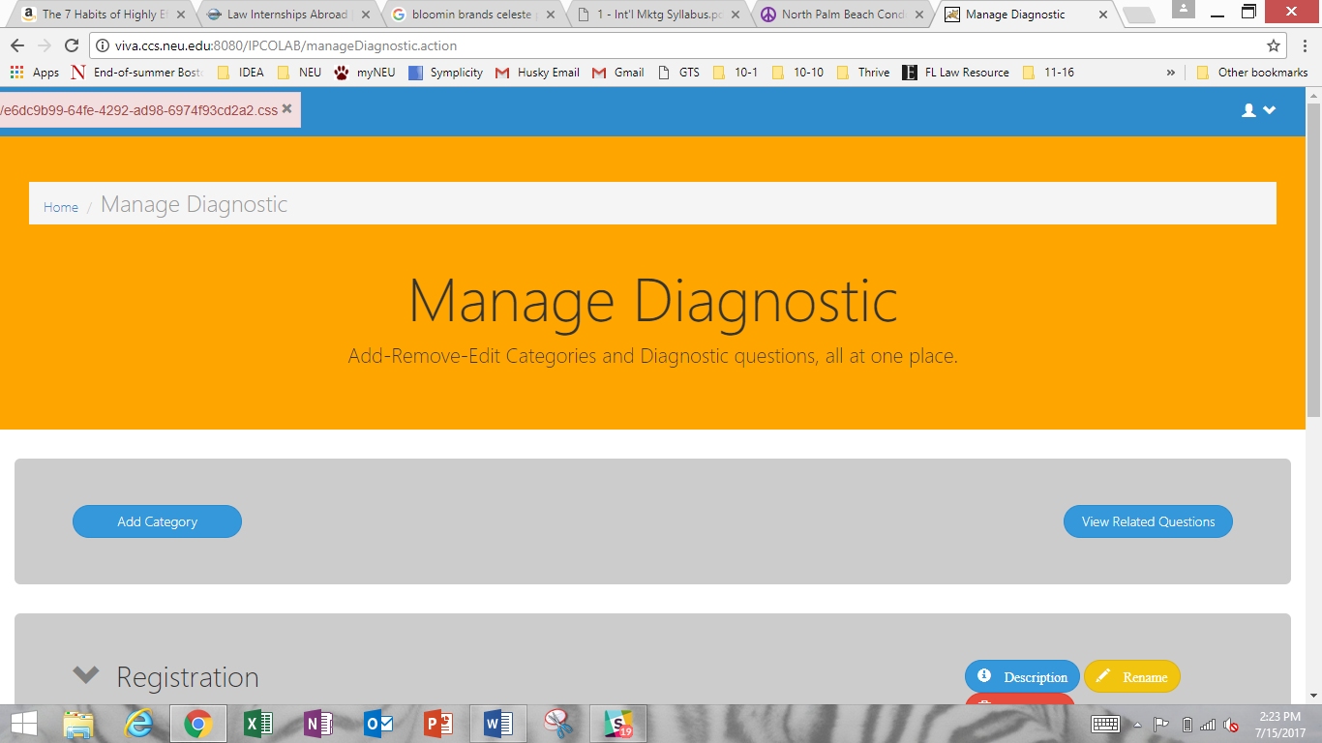

**ADDING DIAGNOSTIC CATEGORIES**

To add a Diagnostic Category, click “Add Category.”

1. On the next screen, you can add the Category Name at the top and a brief description of the Category in the second text box.

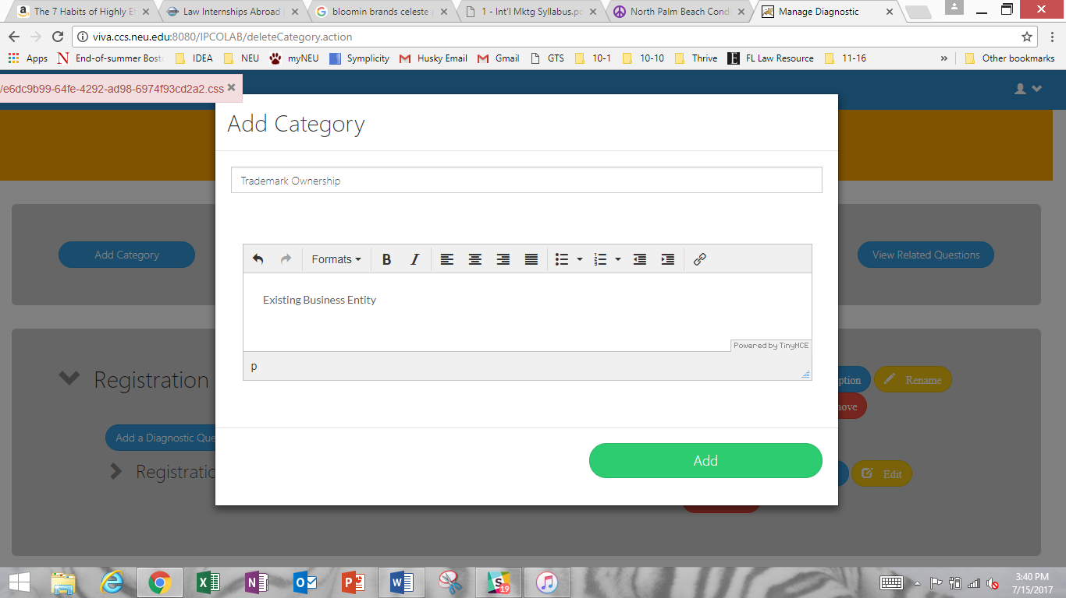

When finished, click “Add.”

1. You will be returned to the “Manage Diagnostic” screen. Scroll down if necessary to find the Diagnostic Category that you just added.

You may now use the Additional Features to View the Category Description by clicking the blue “Description” icon, Rename the Category by clicking the yellow “Rename” icon, or remove the entire Category by clicking the red “Remove” icon. The yellow “Edit” icon allows you to edit the Category Description.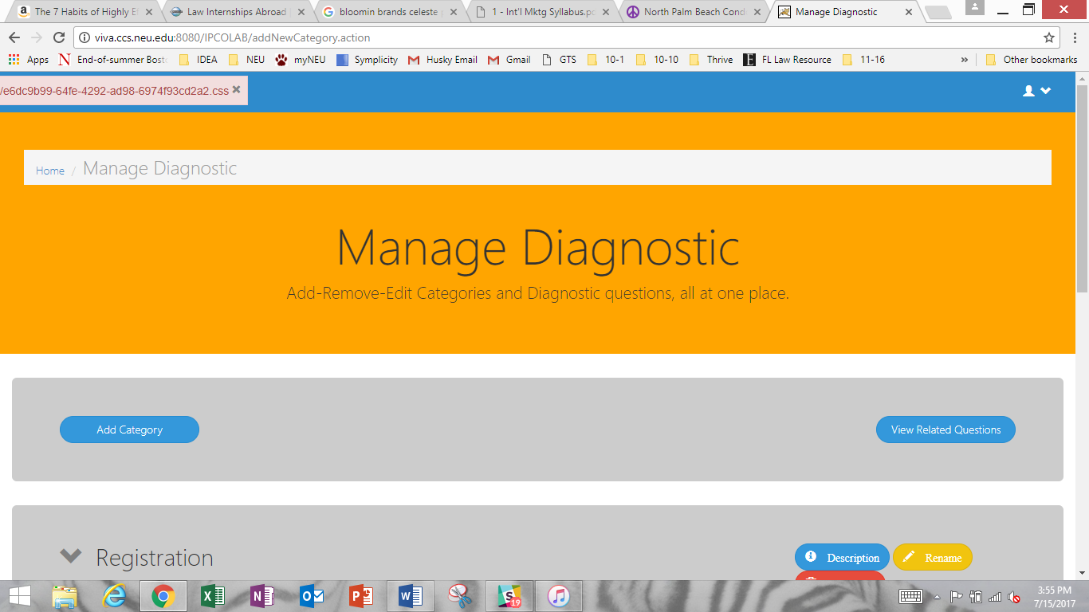

**ADDING A DIAGNOSTIC QUESTION**

1. The next step is to add a Diagnostic Question within the Added Category.

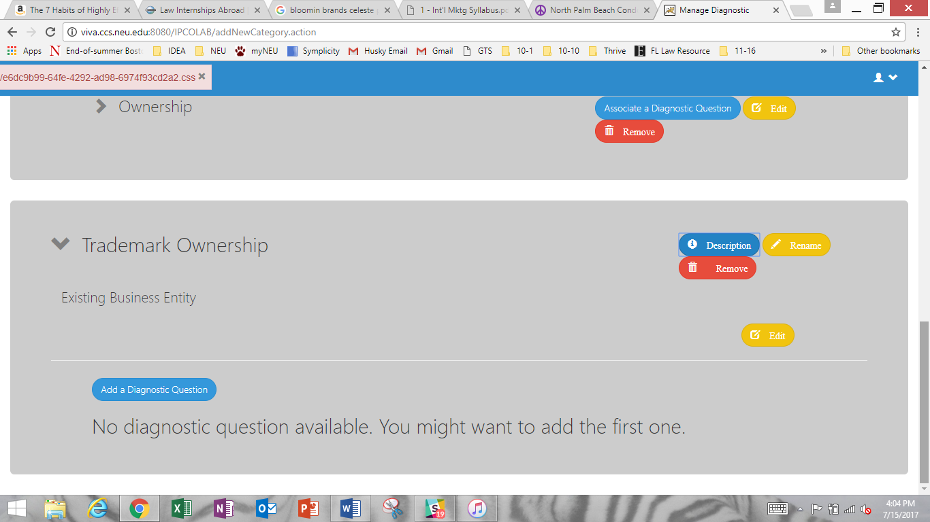

Click “Add a Diagnostic Question” to begin.

1. You will be prompted to complete the “Add-Edit Diagnostic” page, which consists of a six-stage process.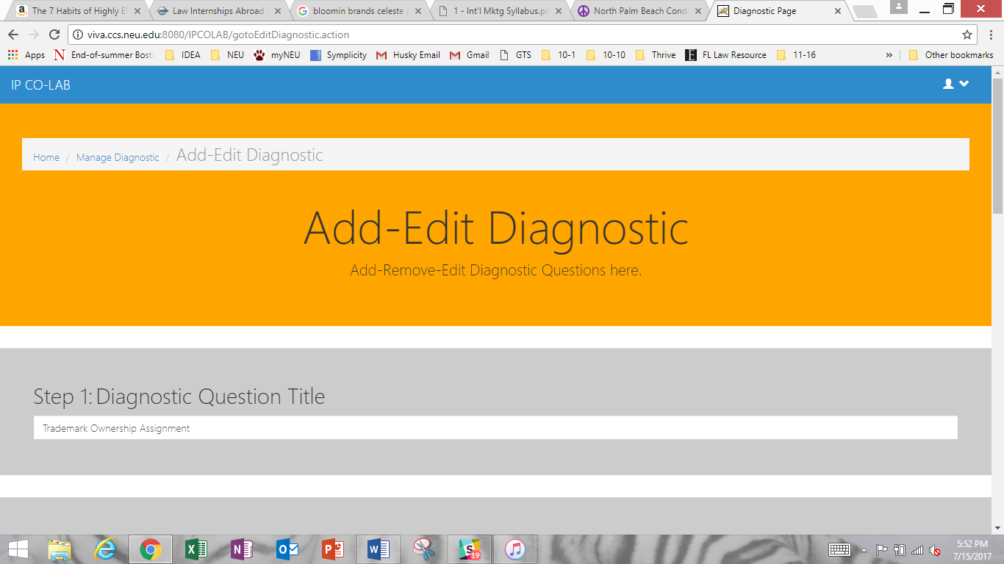

6-1) Fill in the “Diagnostic Question Title” to describe the question.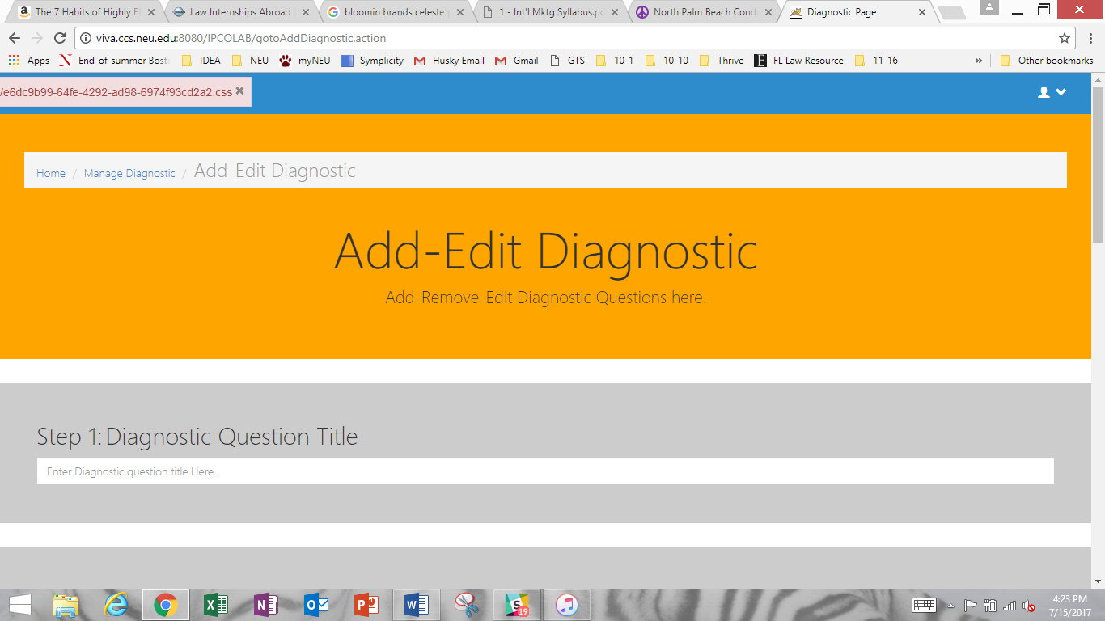

6-2) In the “Diagnostic Description Text” box, type your desired Diagnostic Question in such a way that it may be answered with a “yes” or a “no”.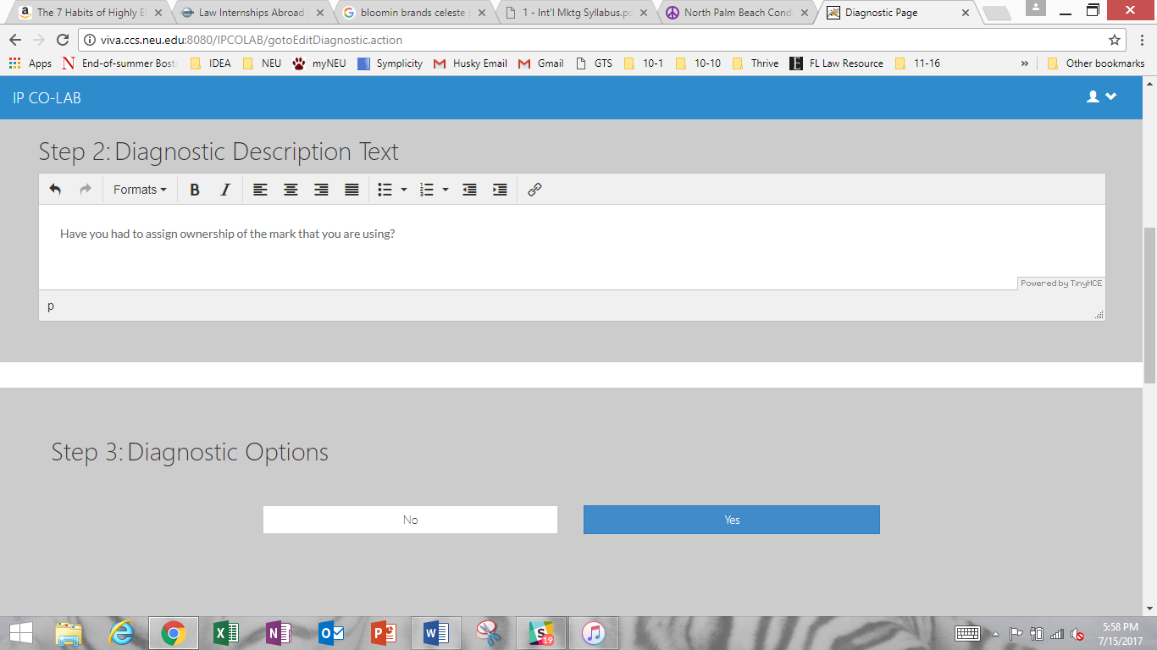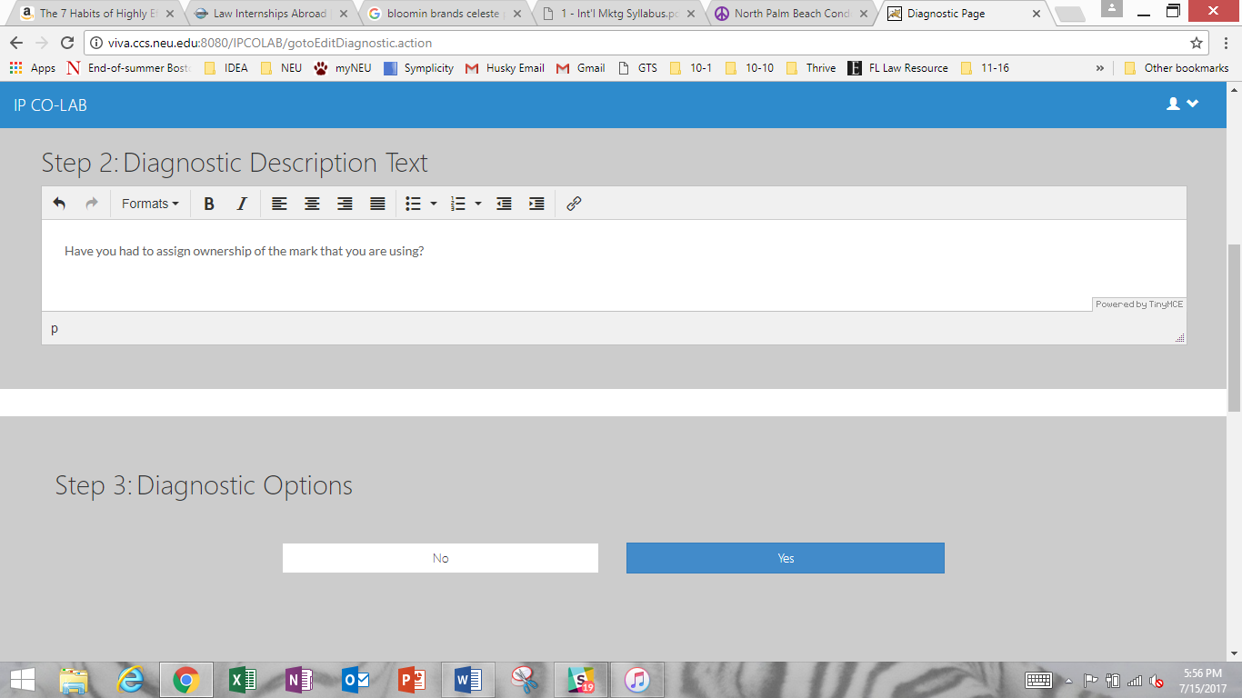

6-3) Based on the question, choose the “Diagnostic Option,” “yes” or “no,” that will trigger the User to be directed to specific Topic information.

**ASSOCIATING TOPICS WITH DIAGNOSTIC QUESTIONS**

6-4) You will next associate any number of appropriate Topics with the Diagnostic Question. Refer to “IP Overview – Adding Content” Section to learn how to add Diagnostic Question Topics. Associating a Topic(s) with a Diagnostic Question results in the content of the Topic(s) appearing to the User if the User’s response triggers the inclusion of the Topic(s).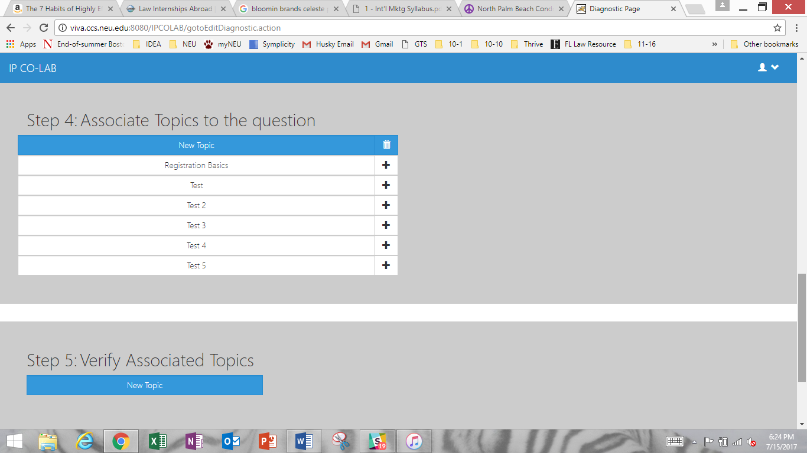

6-5) Next, verify that the Topic(s) you selected are correct.

6-6) Lastly, click “Add” (or “Update” if you are editing a Diagnostic Question) to finish.

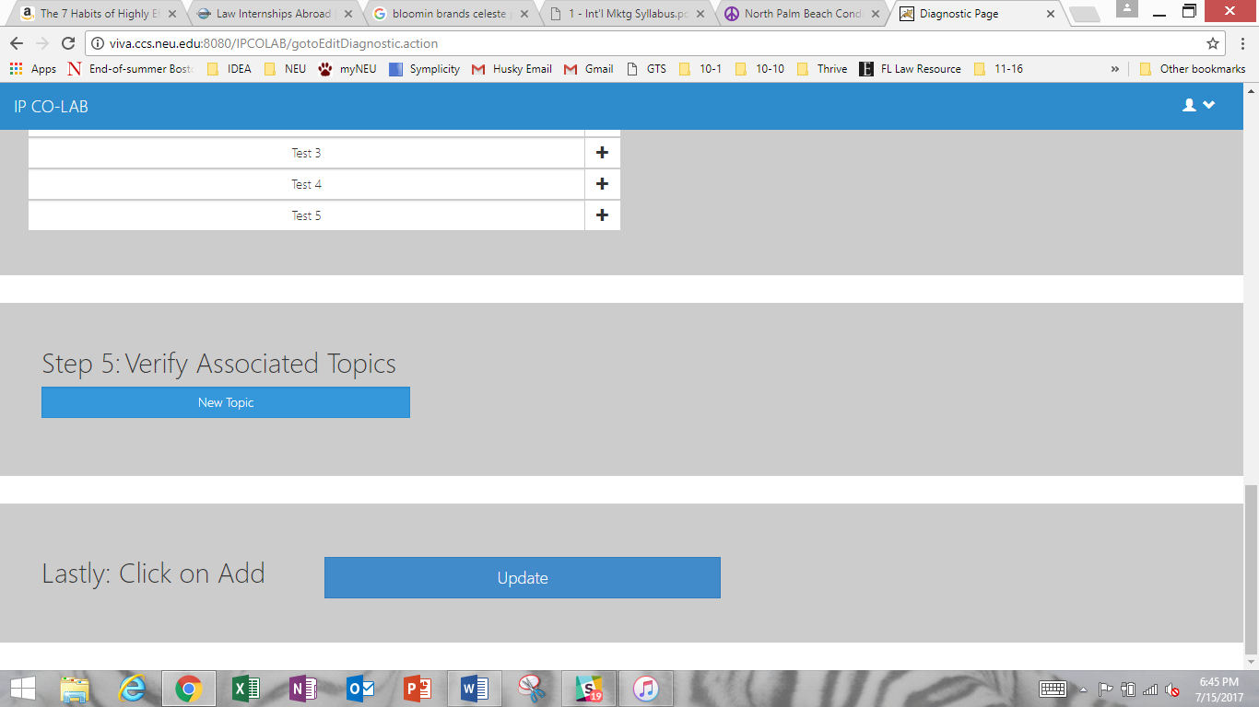

**ASSOCIATING DIAGNOSTIC QUESTIONS (RELATED QUESTIONS)**

By now, you have created at least one Diagnostic Question. Repeat the steps for Adding a Diagnostic Question to create a second Diagnostic Question. Once you have two or more Diagnostic Questions, you may associate any two or more questions so that the combined triggering of each question will lead the User to the Topics that you associated with the associated Diagnostic Questions. It is a useful tool to aggregate circumstances (by creating an association).

1. First click on “Associate a Diagnostic Question” next to the Diagnostic Question that you want to associate.

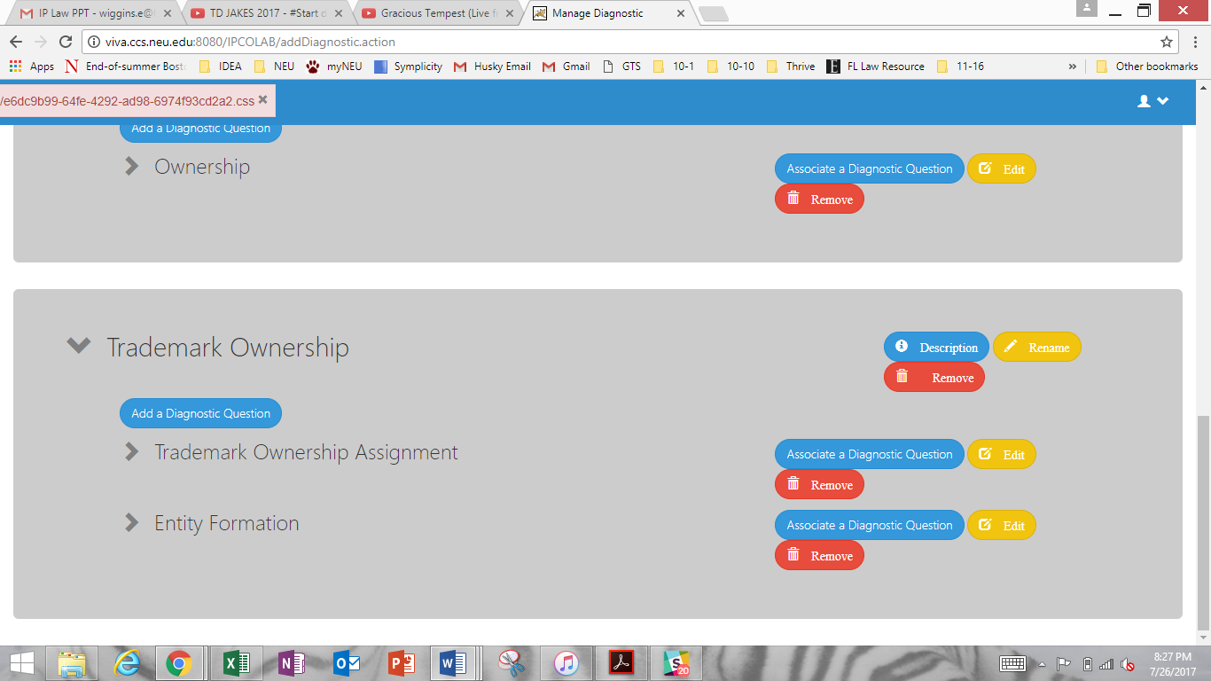

Next, there are six (6) grouped steps to Associate a Diagnostic Question.

* 1. Enter the “Diagnostic Question Title.”

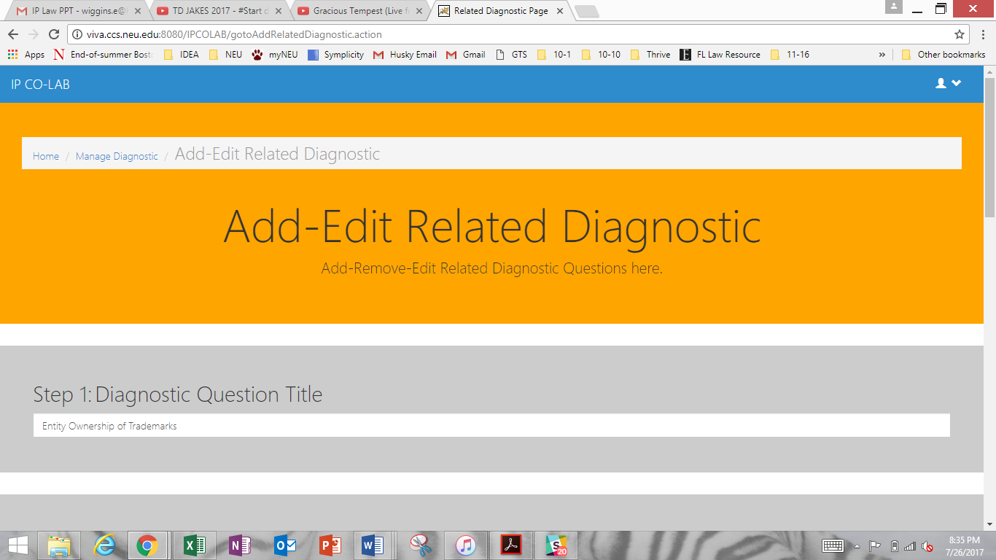

* 1. Select the Diagnostic Questions that you would like to be related. The relationship should lead to the User getting more or more specific information about a general circumstance.

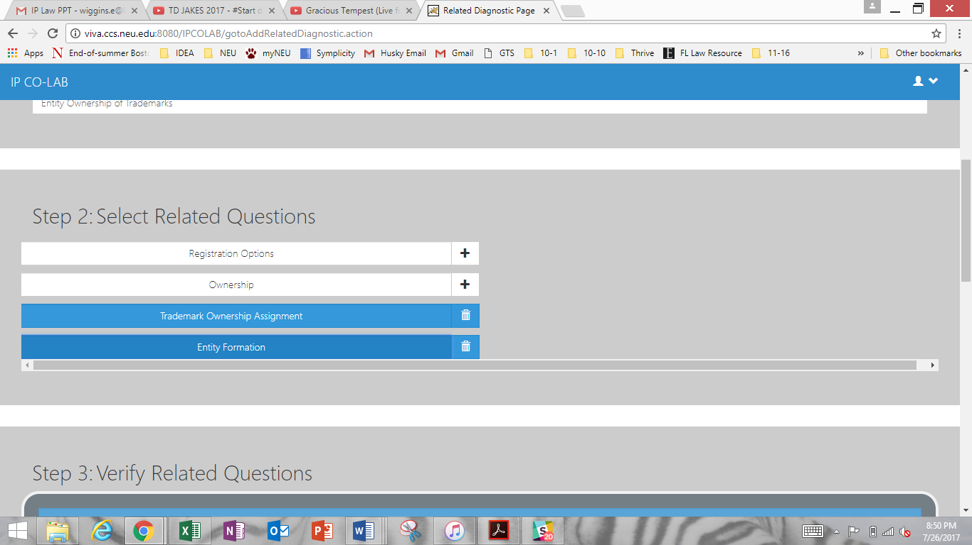

For example, here, the Diagnostic Questions “Trademark Ownership Assignment” and “Entity Formation” have been associated. The association may lead to Topics that discuss what an assignment to a business entity means for the entrepreneurs or how an assignment to the business entity may occur.

* 1. Verify that the Diagnostic Questions that you associated are the correct questions. You will see the title and text of the Diagnostic Questions to facilitate verification.

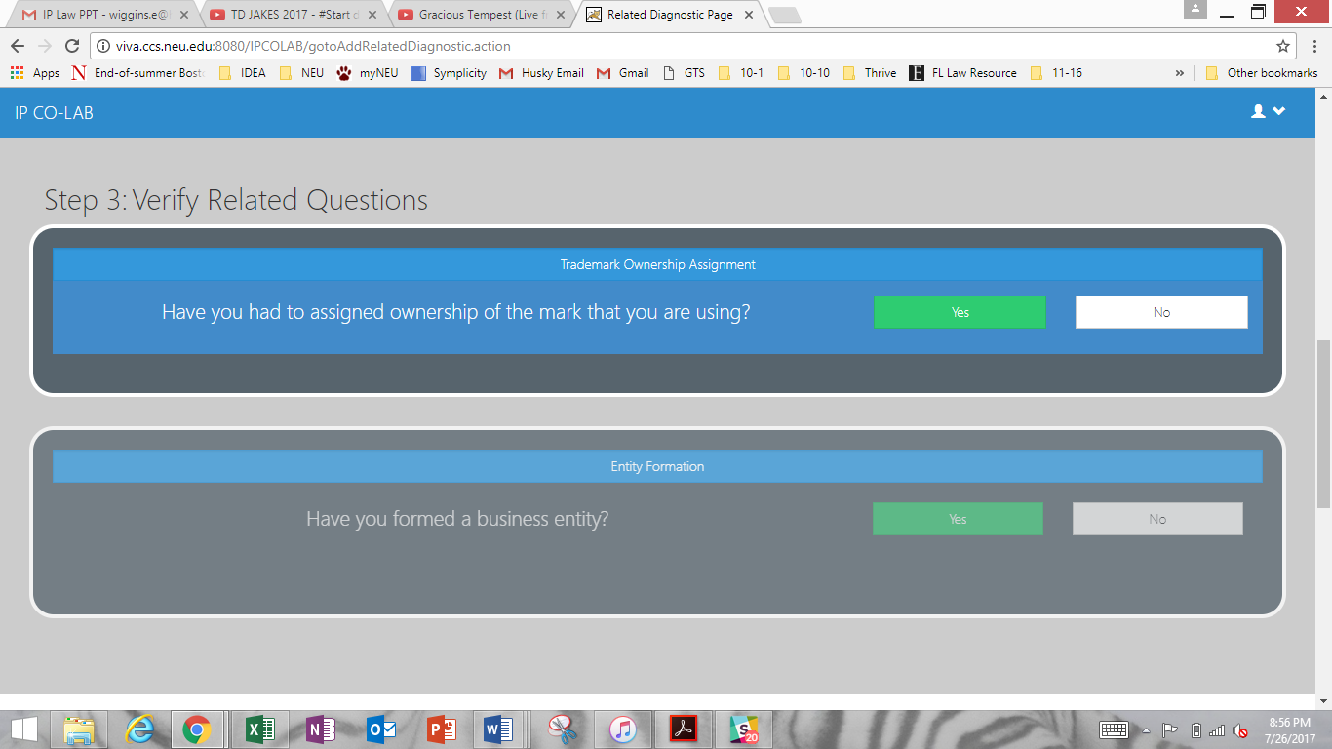

**ASSOCIATING TOPICS TO RELATED DIAGNOSTIC QUESTIONS**

* 1. After verification, you may select the Diagnostic Topics that you wish for a User to see if the User’s responses trigger the Diagnostic Question association.

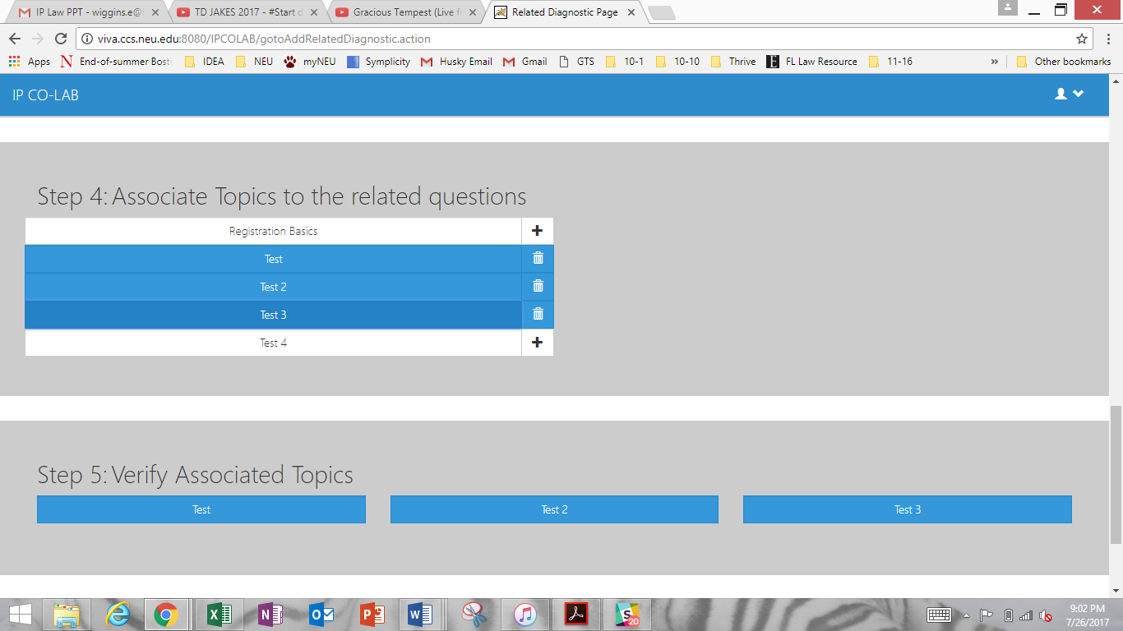

* 1. Verify that the Topics associated to the Related (Associated) Diagnostic Questions are correct.
  2. Lastly, click “Add.”

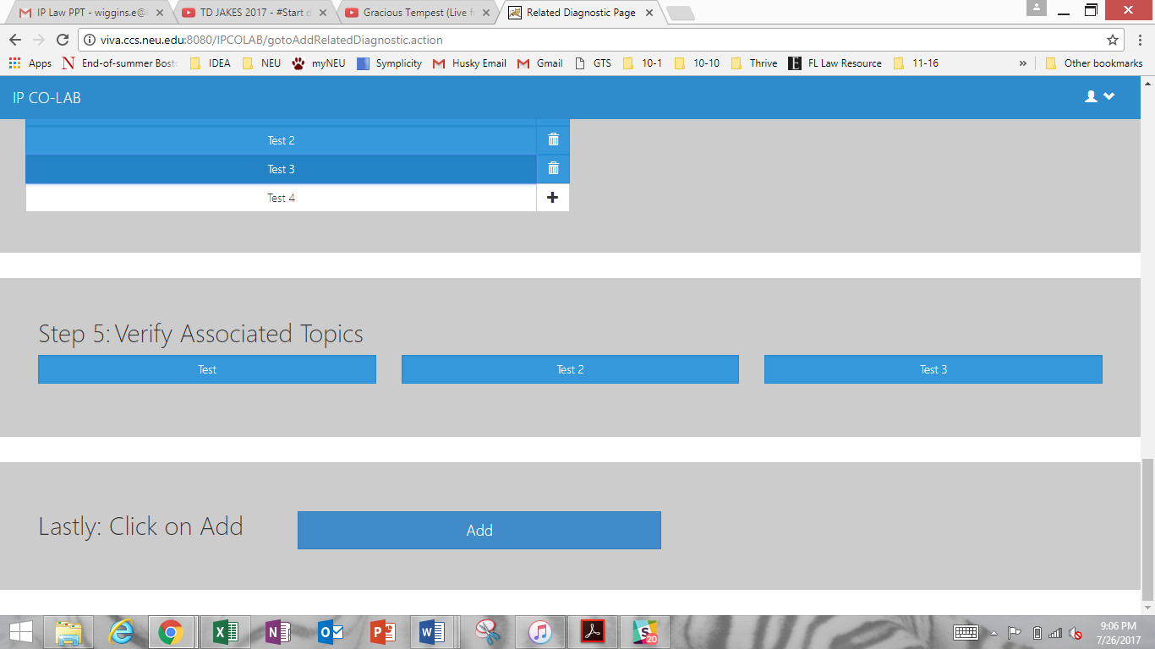

**EDITING RELATED DIAGNOSTIC QUESTIONS**

1. A screen entitled “Manage Related Diagnostic” will appear after you click “Add.”

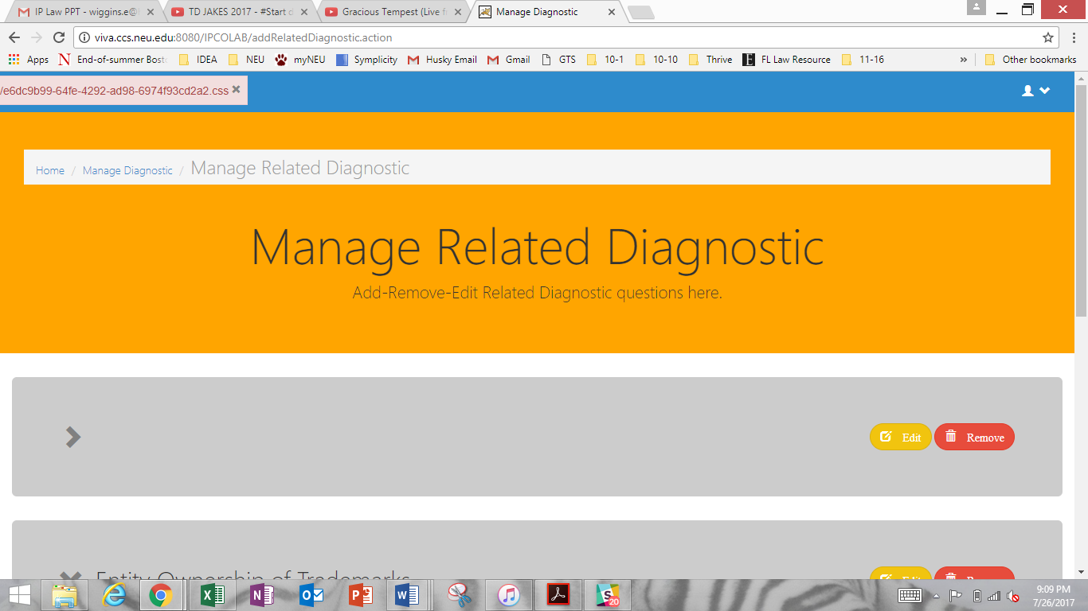

Here, you can select the yellow button to “Edit” or the red button to “Remove” the Related (Associated) Diagnostic Questions.

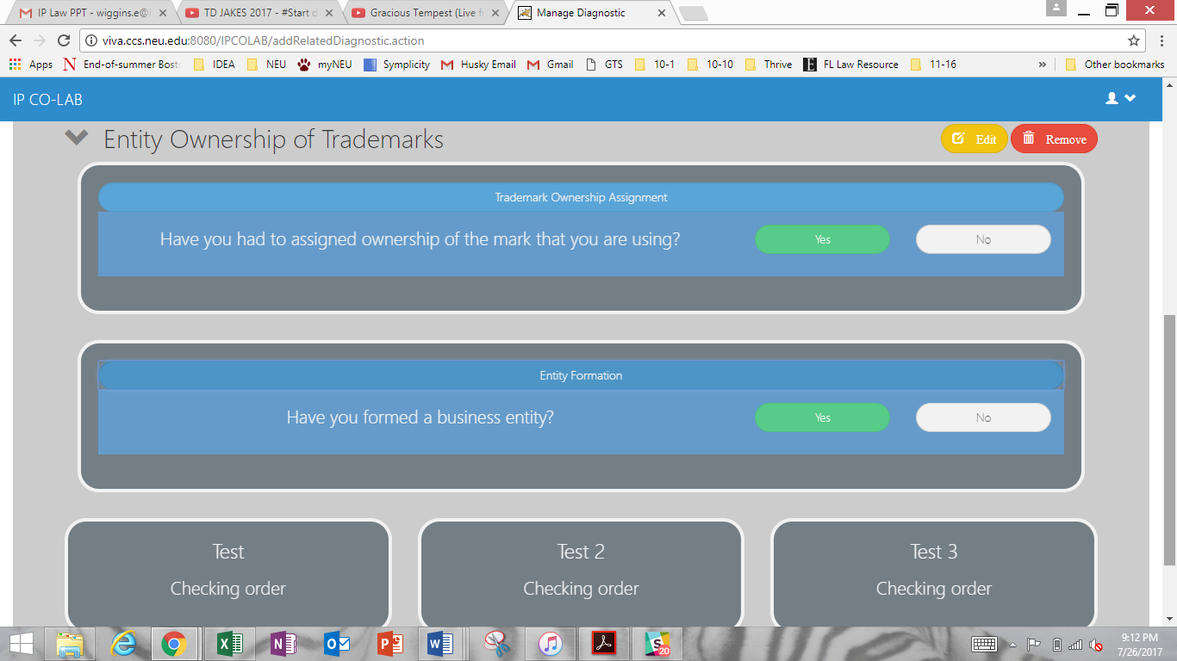

You may review the titles and text of each Related Diagnostic Question and the Topics associated with the relation.

1. If you return to the “Manage Diagnostic” page, you may also access to Related Diagnostic Questions by clicking “View Related Questions” at the top of the page.

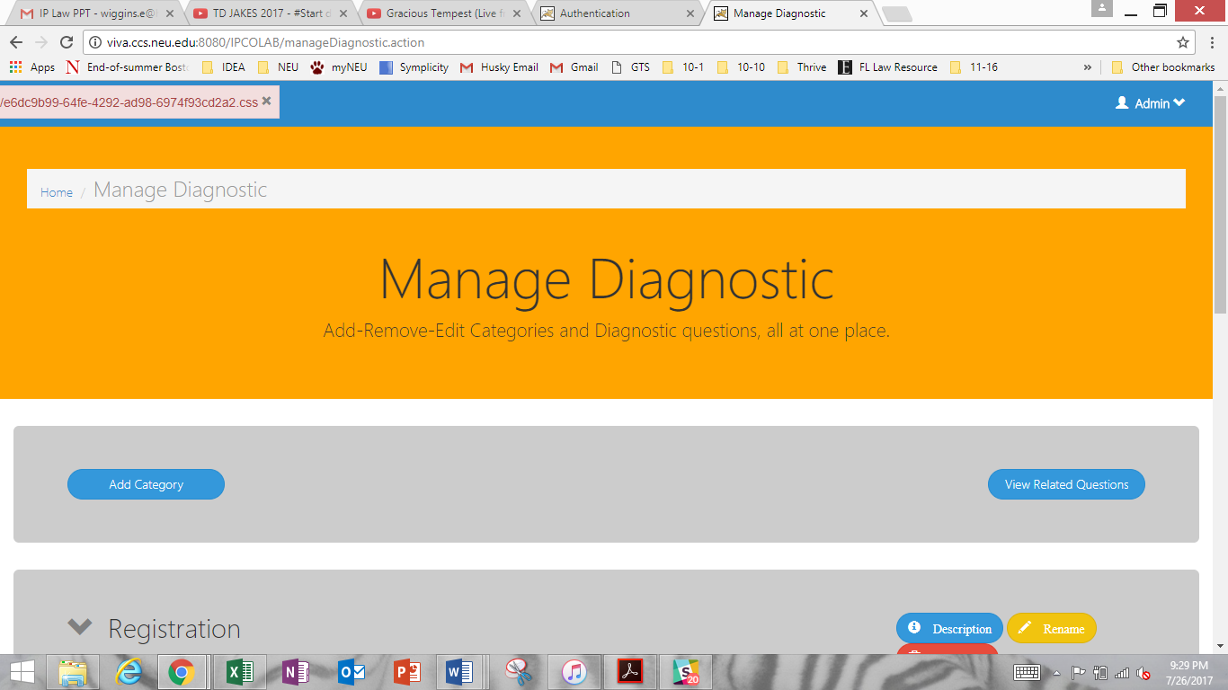

Once you have explored these steps, you may repeat any that are necessary to populate the platform.

1. **Administrator Quiz**
   1. **Summary**

The purpose of the Quiz is to allow Users to test their knowledge of the IP concepts they learned in the other sections of the Module.

As always, the combination of the Quiz information and activities and subsequent legal information do not constitute legal advice under any circumstances. All Quiz Modules and Activities are and should be tailored to suit generic situations. All information is general and suited for the generic situation, but not for factual nuances that the User may be facing.

* 1. **Inputting Content**

1. Below, you will find the Administrator Home screen.



To access the Quiz, click “Quiz.”

1. You will arrive at a “Manage Quiz” page where you can add, remove, and edit Quizzes.

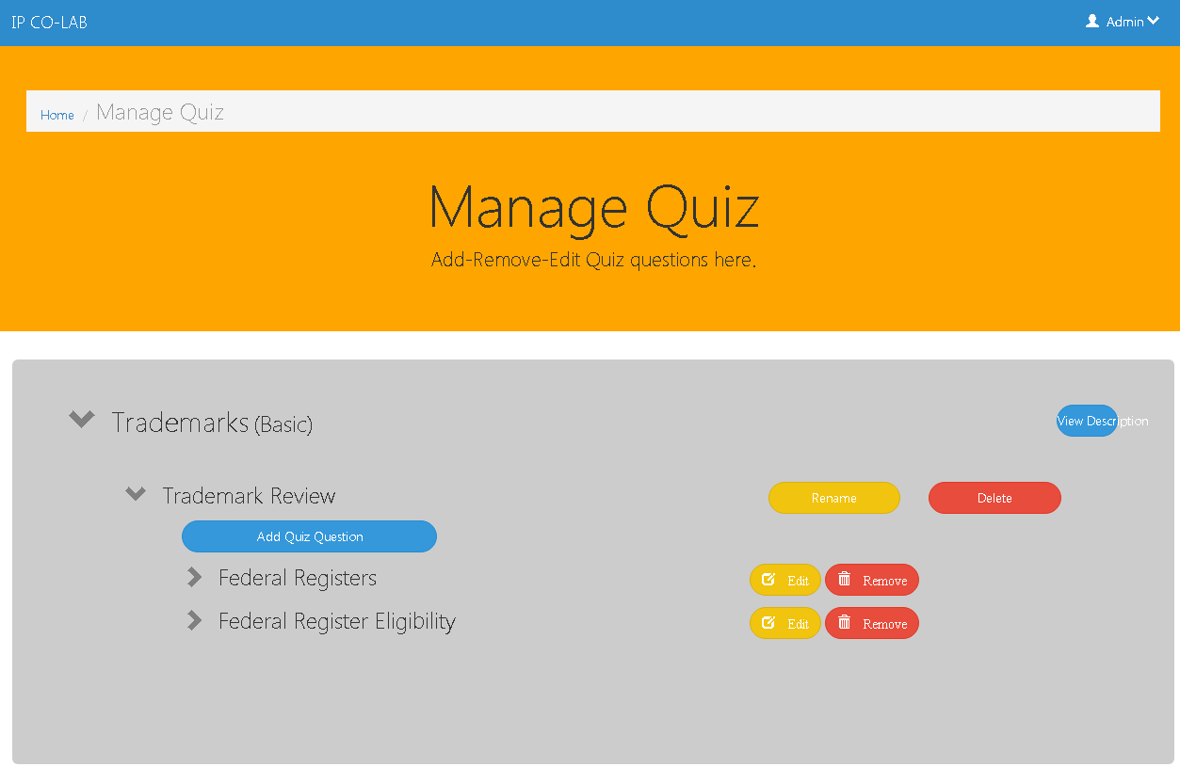

Note: The headings for the quizzes (in the screen capture above, “Trademarks (Basic)” are pulled from the Topics you create in the Tutorial.

To add a new Quiz, click “Add Quiz Question.”

1. Proceed through the next five steps.

3-1) Choose the Quiz template format, either Multiple Choice or Yes and No.

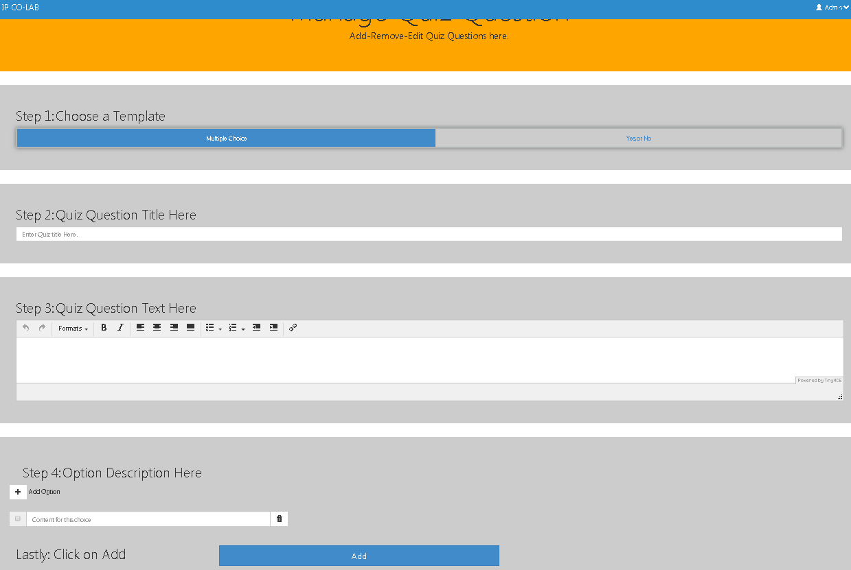

3-2) Enter the Quiz name, if any.



3-3) Enter the Quiz question.

3-4) For the Multiple Choice template, click on the “+ Add Option” icon to add answer options. Select all correct answers by clicking on the small square next to the answer options.



When finished, click “Add.”

The new quiz question will appear on the main page (see below). In this example, the question is a multiple choice. The answers you chose as the correct answers to the question are indicated by a small check mark in the box next to the answer. On this screen, you may also rename, edit or remove the quiz or quiz question.

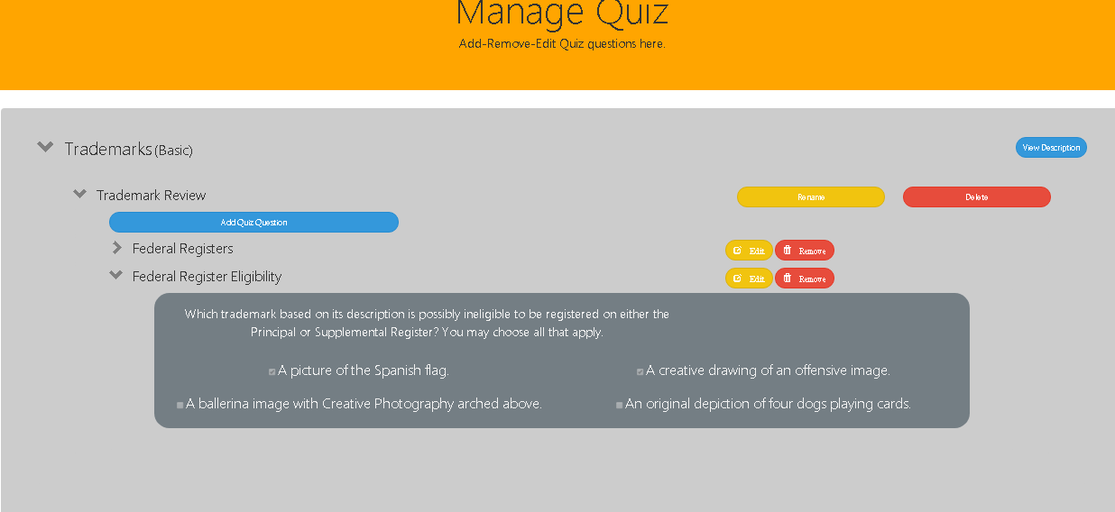

1. **Administrator User Functionality**
   1. **Summary**

Administrator(s) may access User information through the User functionality. This information includes the User’s Name, Role, Date of Registration, Last Login Date, and a Progress Report. An Administrator cannot edit any of this information. An administrator may only view or sort based on the information, or delete a User account if deemed necessary.

The primary purpose of the User Functionality is to track whether Users are completing activities and the timeframe of completion. User Functionality is also useful to an IP CO-LAB member who is working with a venture. The member may require that the venture complete specific Categories during the length of the project, and may view the venture’s progress. Overall, the User Functionality is intended to give the IP CO-LAB feedback as to the platform’s usage by and usefulness to the Northeastern entrepreneurial ecosystem.

* 1. **Viewing User Roles and Information**

1. From the Home screen, select “User.”

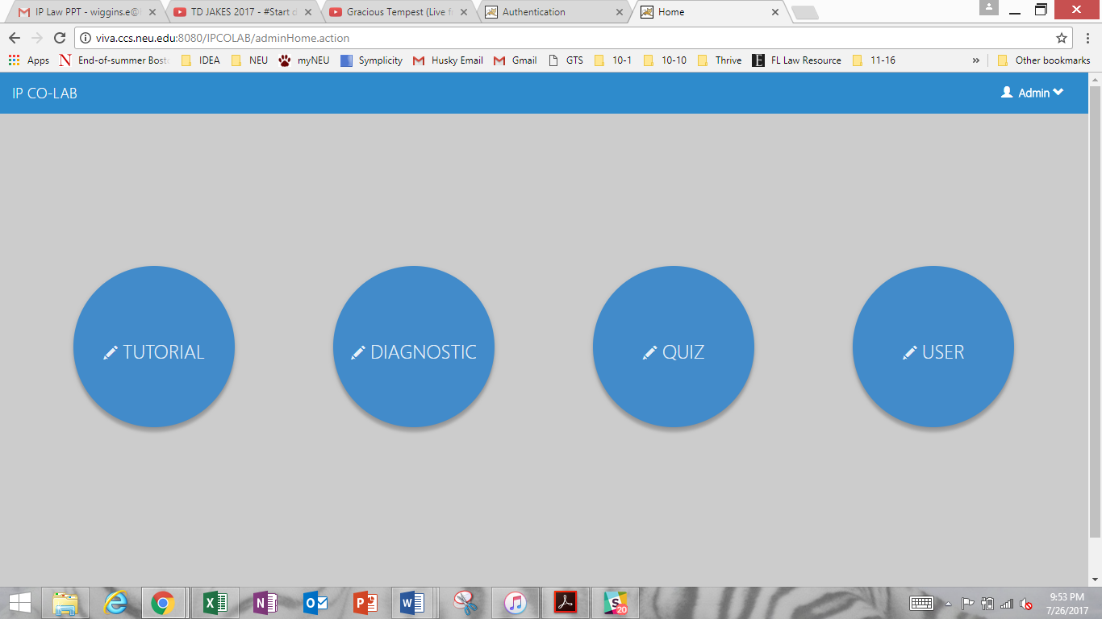

1. The “Manage User” screen will appear.

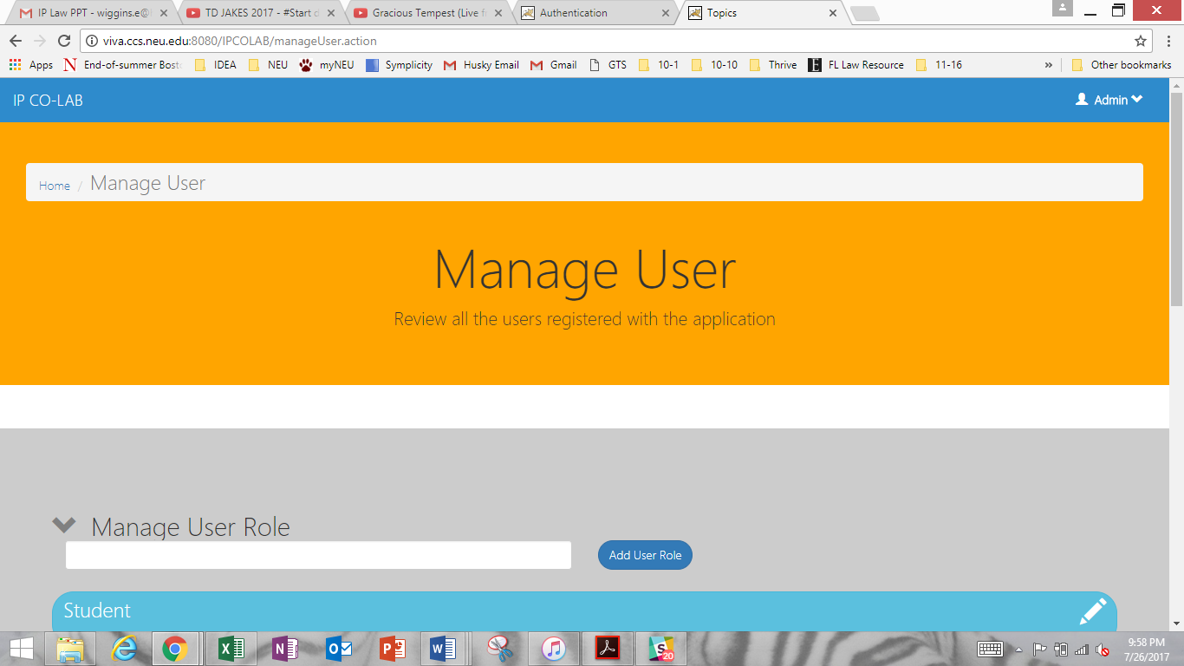

1. Scroll down to view the “User Roles.” You may add a role by clicking “Add User Role,” or edit an existing role by clicking on the pencil icon.

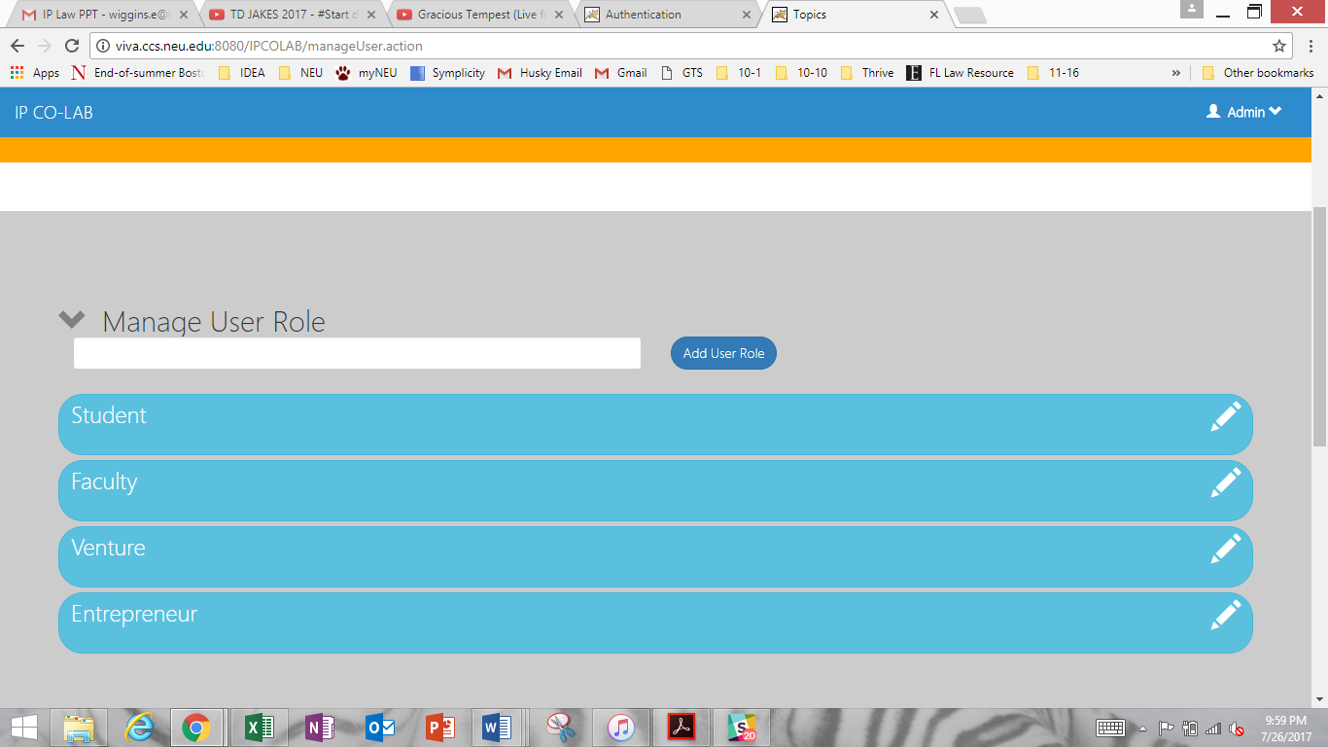

1. Scroll down to find registered Users.

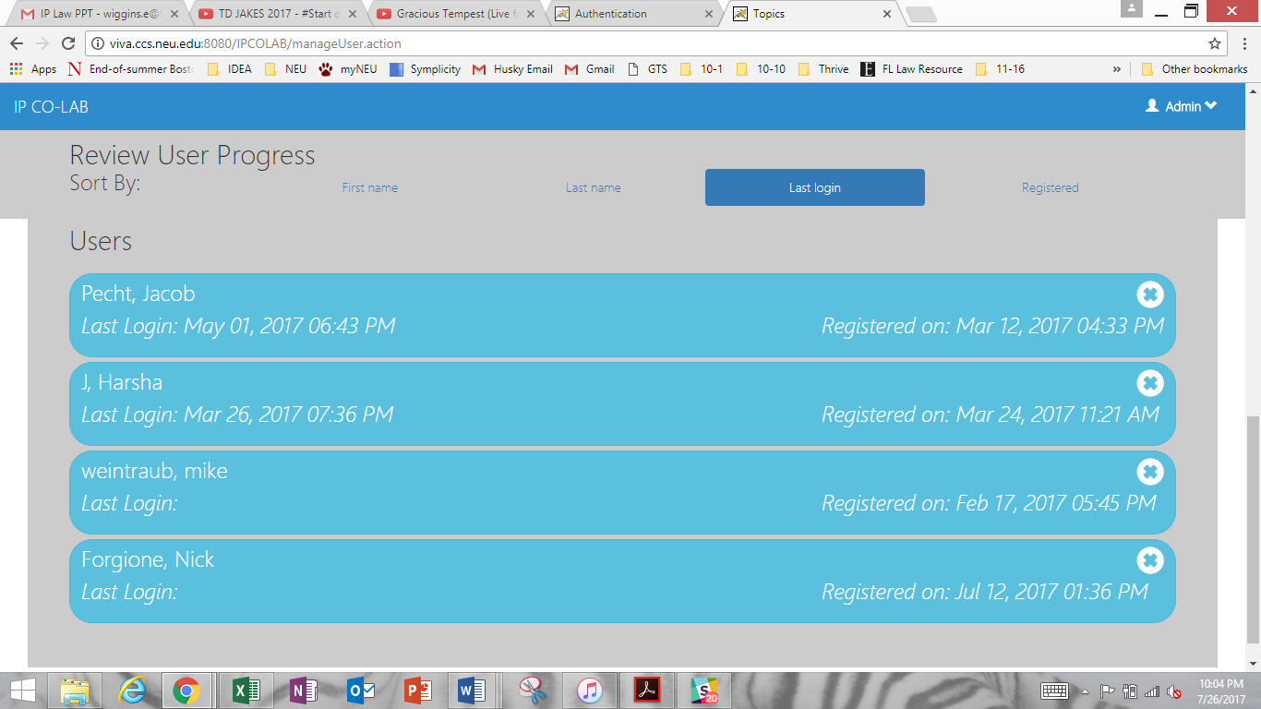

1. To sort Users, click on any of the top four characteristics: First Name, Last Name, Last Login, or Registered.



1. To review any User’s progress, click on a User.



1. You can view the User’s profile, including the Basic Overview and Tutorial (Diagnostic Test) Instances or sessions that the User has initiated.

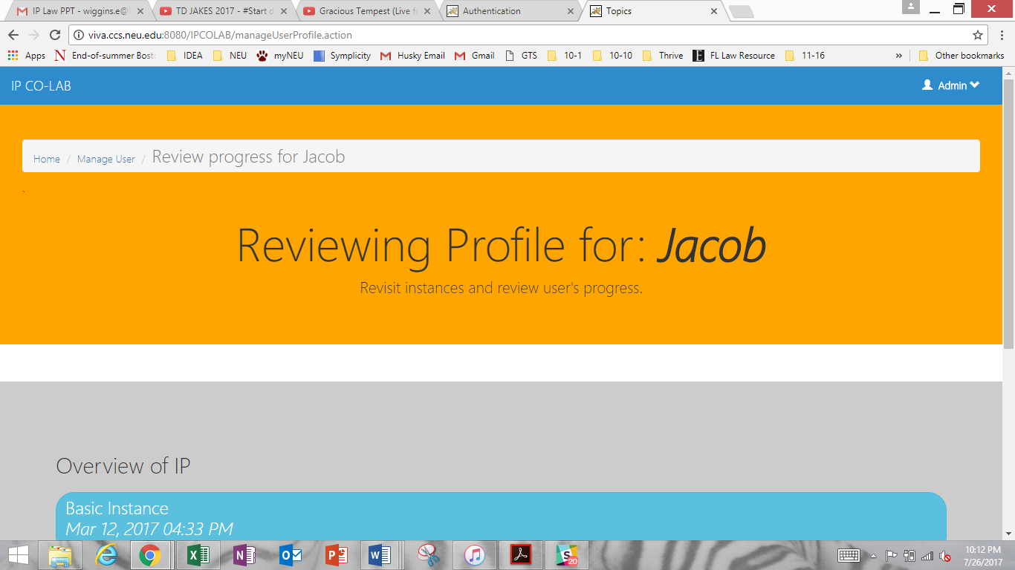

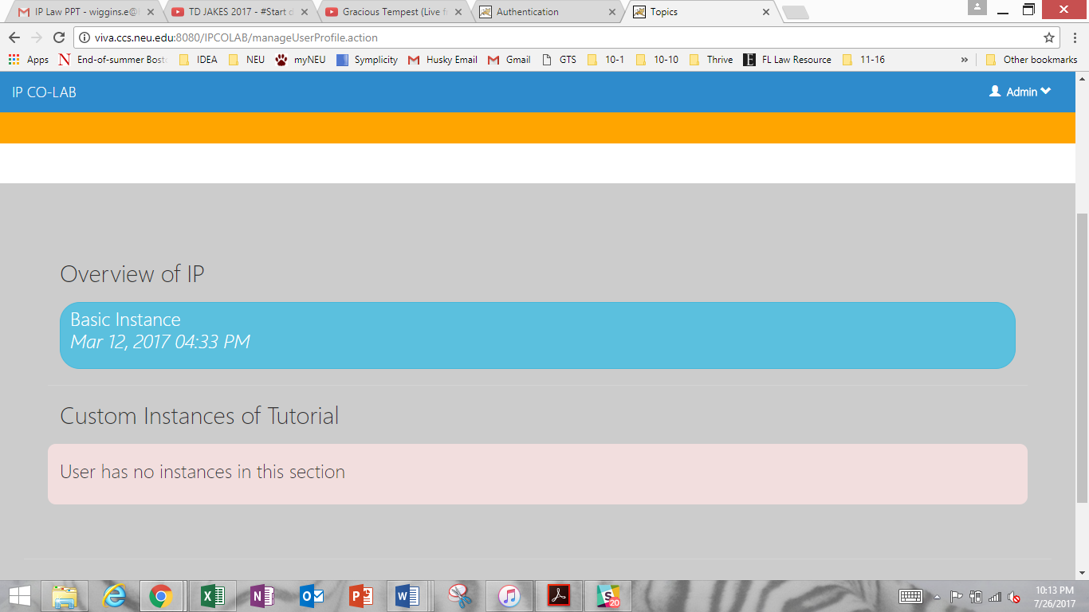

1. By clicking on any session under “Overview of IP,” you will see all Topics that the User must complete and the progress of each Topic indicated by a percentage at the far left of the bar.

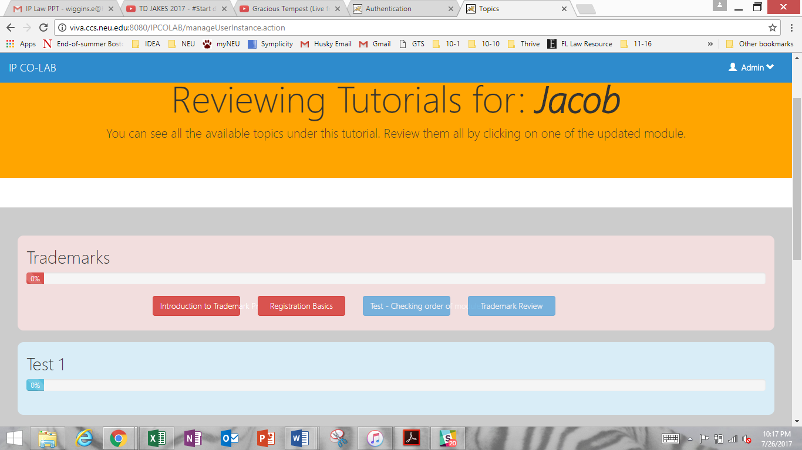

1. To view the Activities that are within a Module, click on the Module.
2. The Module will appear highlighted on the next screen.

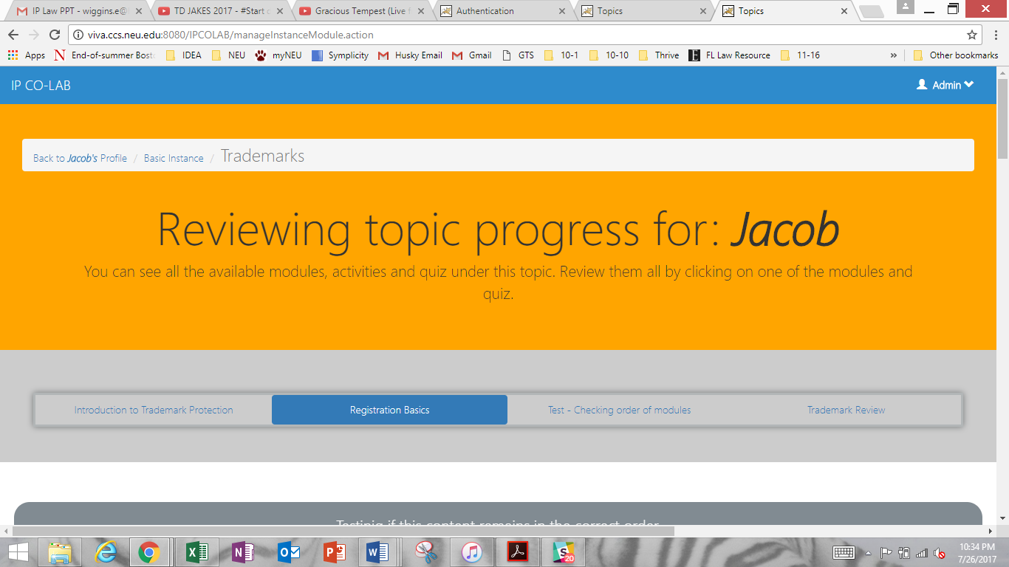

1. Scroll down to view Activities. Correct answers are highlighted in green.

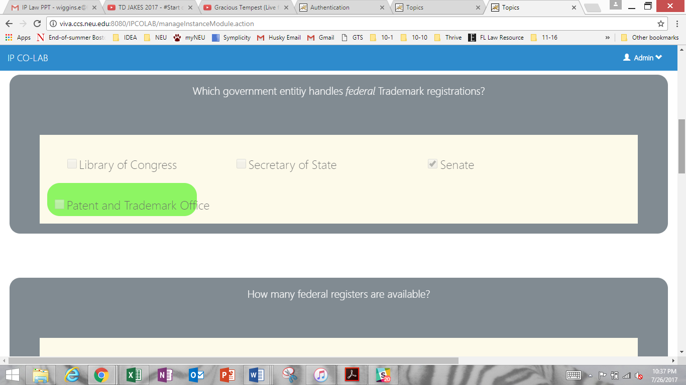

1. Scroll up to the top of the page. Use the navigation bar to return to the User’s profile.

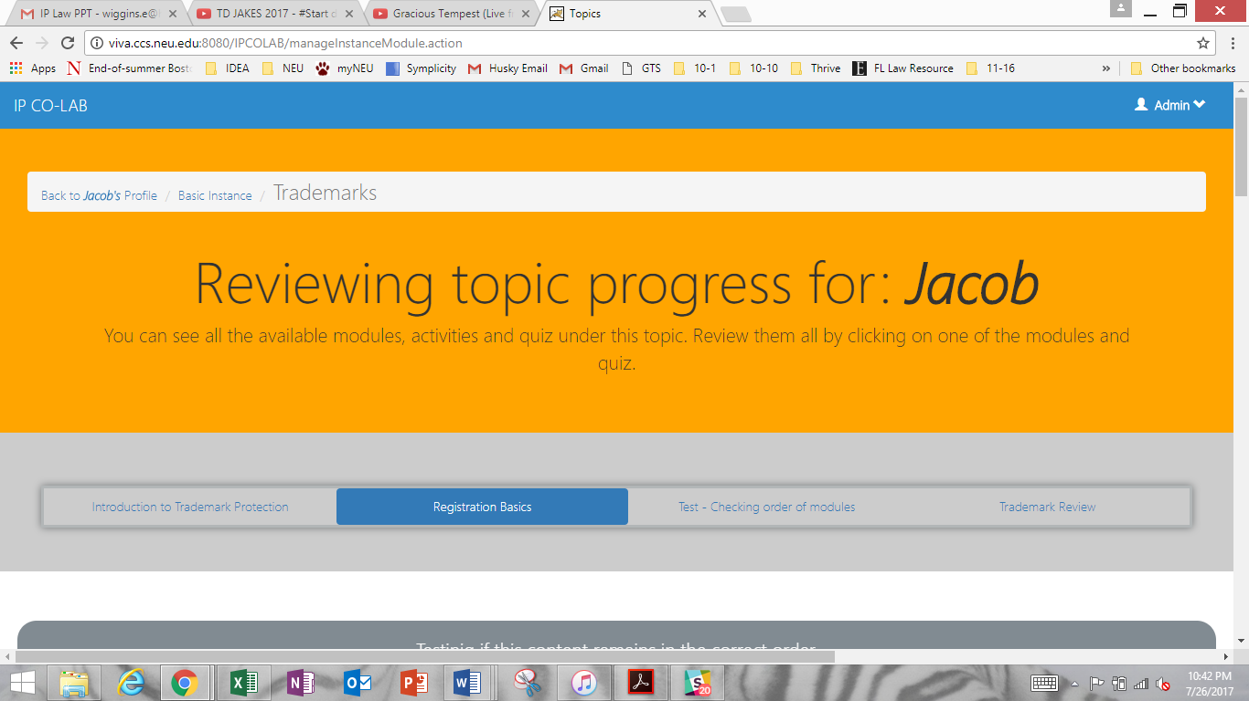

1. If the User has initiated a “Tutorial” (Diagnostic Test) session, click “Custom Instances of Tutorial” to view.

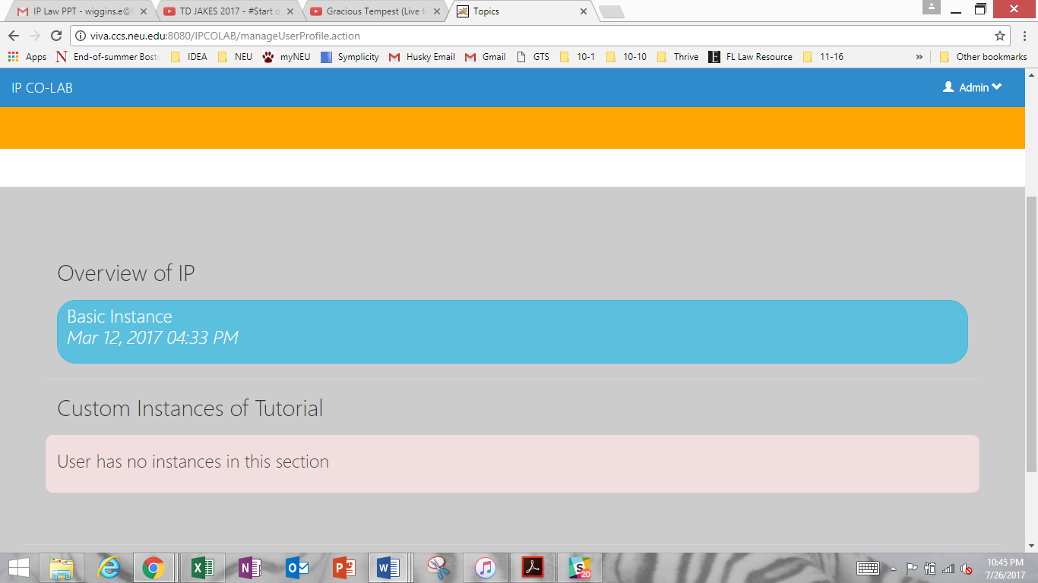

1. Use the navigation bar at the top of the page to return to the “Manage User” page.

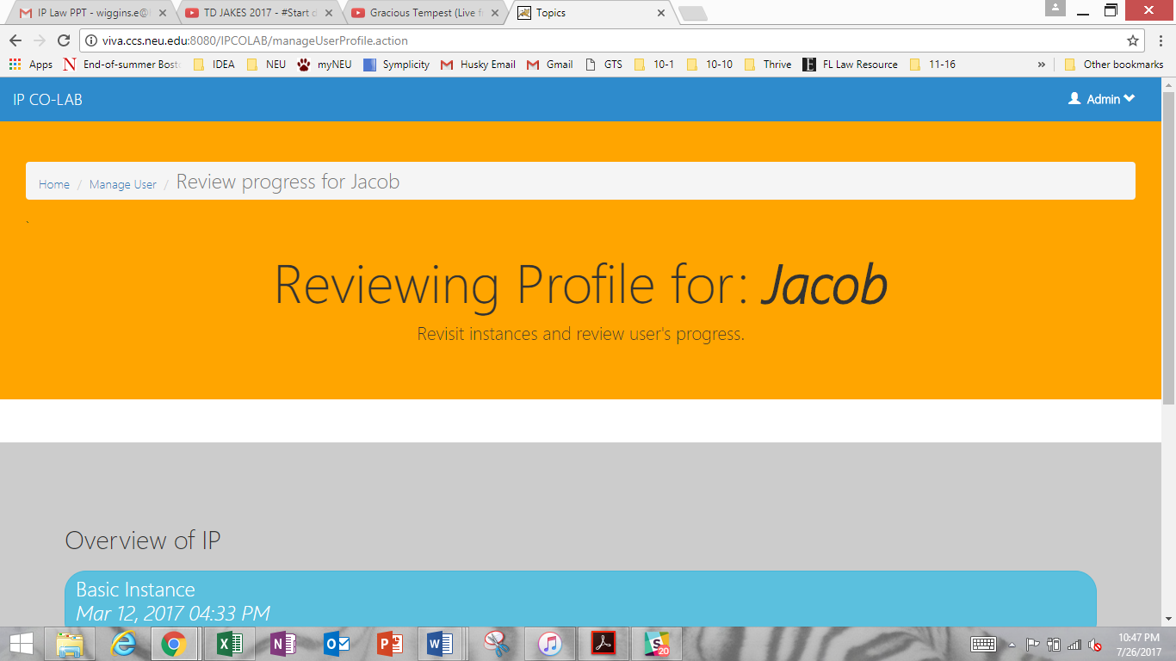

1. If you attempt to delete a User account, you will be asked for confirmation.

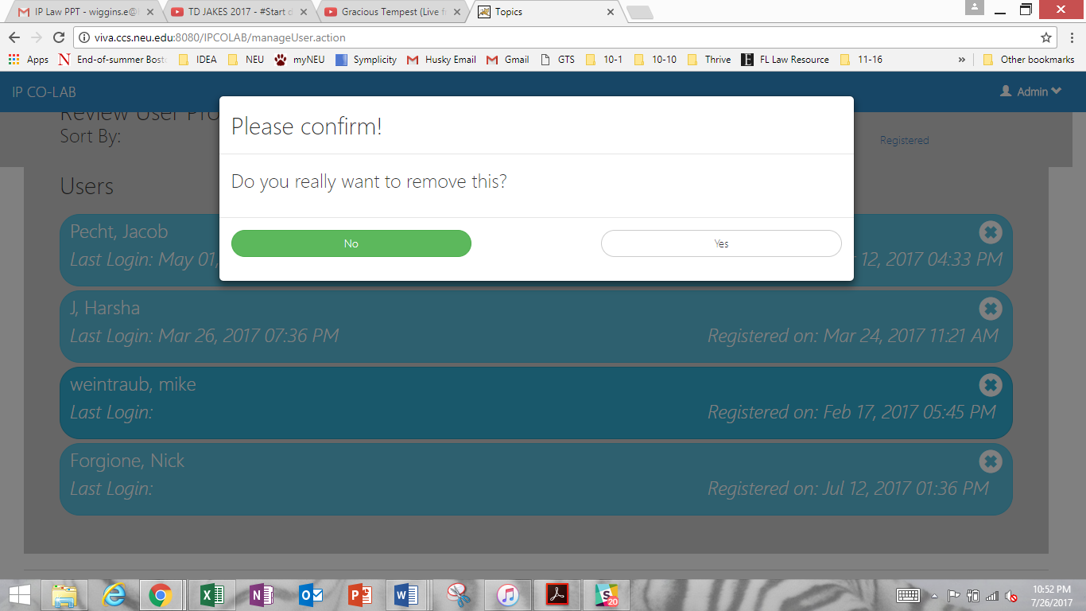

Repeat the above steps for any User Profile.